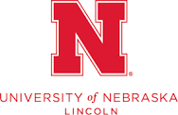

Call for Conference Proposals
Language, Migration, and Education: Cultivating Linguistic and Cultural Diversity

University of Nebraska-Lincoln

College of Education and Human Sciences

Carolyn Pope Edwards Hall

Lincoln, Nebraska

Saturday, September 9, 2023

8:30 am – 2:00 pm CST

Featuring Keynote Speaker: Dr. Ofelia García

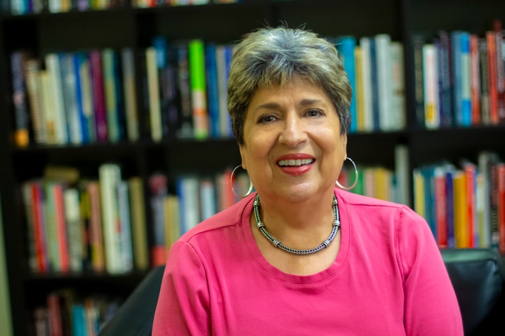

The M3 (migrant, multicultural, and multilingual) Initiative together with the Department of Teaching, Learning and Teacher Education at the University of Nebraska-Lincoln aims to build community and increase presentation and networking opportunities among students, teachers, teacher educators, and researchers interested in the intersection of language, migration, and education. As such, we invite proposals for presentations in all areas related to our conference theme, including (but not limited to):

- Language, migration, and education
- Linguistic rights
- Bi/Multiliteracies
- Indigenous language revitalization/Language loss
- Multilingual Pedagogies including translanguaging
- Transnational migration and schooling
- Colonial legacies, war, conflict, and education
- Climate change and migration

We encourage proposals that focus on educational settings (e.g., PreK-12, community college, or university). Priority will be given to proposals that intersect with the conference theme topics.

DEADLINE: Proposals must be received by Monday, March 27th, 2023. Participants will be notified if their proposal is accepted by May 30, 2023.

Submission Process:
Submit a 250-300 word abstract, with title, and a second page with references.

- Please remove any identifying information from the abstract.
- Submit your proposal here
- Registration costs $10 and participants can register here

The conference will be held in person on the University of Nebraska-Lincoln campus in Carolyn Pope Edwards Hall.

Conference contact:
Dr. Theresa Catalano tcatalano2@unl.edu
Contact Cathy Gabell (cgabell1@unl.edu ) for questions about conference registration.

