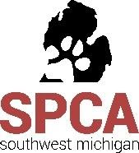
DOG-O-WEEN
SATURDAY, OCTOBER 24, 2020
Deadline to Submit Form: Saturday, October 17, 2020
BENEFITING THE SPCA OF SOUTHWEST MICHIGAN
A NON-PROFIT, NO-KILL ANIMAL RESCUE & ADOPTION CENTER

Our annual Dog-O-Ween party is an exciting family-friendly day of Halloween-themed games, events, contests, vendors, and prizes!
With a variety of sponsorship tiers available, this is a great opportunity to spread the word about your business to the bustling Kalamazoo community—all while supporting a great cause!
PREMIUM SPONSORSHIP: Minimum Donation $500

Prime table space under our event tent, or in our lobby
Recognition of your support on all printed promotional material, the SPCA website, and Facebook
Announcements thanking you for your sponsorship during our event
The option to include your promotional materials in goodie bags given to our many participants
2 minutes to speak to our crowd about your business during peak time
An individual from your group to stand as a judge during our costume contest!

SUPPORTING SPONSORSHIP: Minimum donation $250

Table space under our event tent
Recognition of your support on all printed promotional material, the SPCA website, and Facebook
Announcements thanking you for your sponsorship during our event
The option to include your promotional materials in goodie bags given to our many participants
An individual from your group to stand as a judge during our costume contest!

BOOTH SPACE AVAILABLE - $50

We are also seeking vendors who would like to be represented under our event tent! Please contact the SPCA of Southwest Michigan for our vendor application.

THANK YOU!
Your generous donation is greatly appreciated!
Visit our website to learn more about us www.spcaswmich.org
The SPCA of SW Michigan is a registered 501 (c) 3 non-profit organization

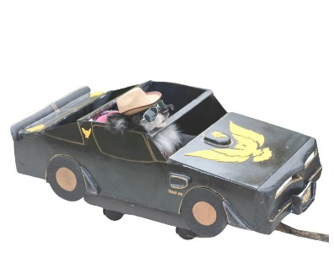

DOG-O-WEEN
SPONSORSHIP INTENT FORM

SPONSOR NAME: _______________________________________________________________________________
(Please put how you would like your name or business name to appear)

CONTACT PERSON (if different than above): _________________________________________________________

ADDRESS: _________________________________________________________________________________

CITY: __________________________STATE: ________________ ZIP: _______________

PHONE: ( ) _____________________ FAX: ( ) ____________________________

EMAIL ADDRESS: _____________________________________________________

EVENT SPONSORSHIP COMMITMENT:

__________ PREMIUM SPONSOR - MINIMUM DONATION $500

__________ SUPPORTING SPONSOR - MINIMUM DONATION $250

__________ OTHER (MONETARY DONATION TO HELP COVER EVENT EXPENSES)

IN-KIND DONATIONS, GOODS AND SERVICES USED AT THE EVENT (Please include estimated value):
_____________________________________________________________________________________

TOTAL DONATION: ______________________ PAYMENT ENCLOSED: ________INVOICE ME: _________

AUTHORIZED SIGNATURE: __________________________________________________________

Please return your Sponsorship Intent Form on or before Saturday, October 17, 2020 to ensure your spot to:

SPCA of SW Michigan Attn: Dog-O-Ween or email: info@spcaswmich.org
6955 West KL Ave. Kalamazoo, MI 49009

