All Ages Book Ideas for Queer & Trans Family Support
Looking for more books? Check out Mombian.com’s extensive LGBTQ+ book database or ask your local librarian!
(
Parenting/Family Books
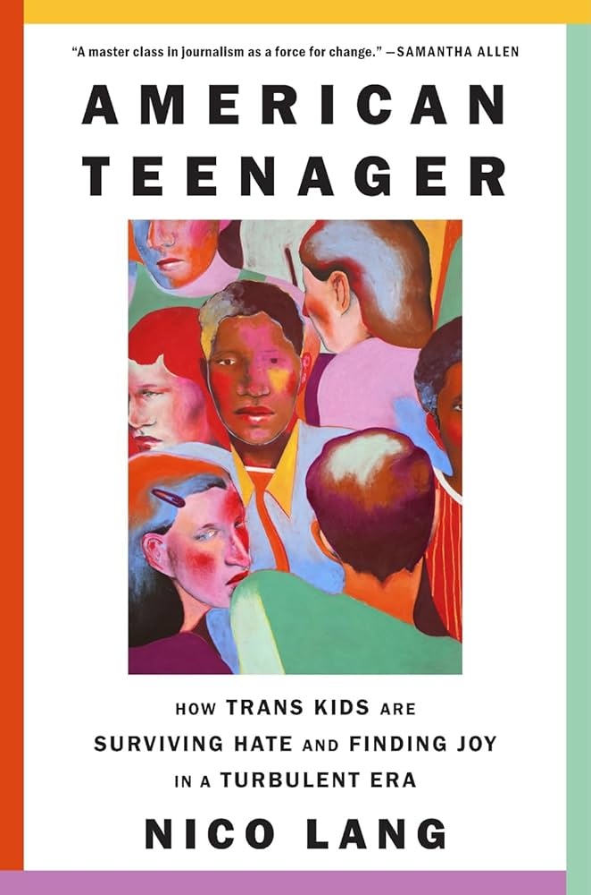
American Teenager: How Trans Kids Are Surviving Hate and Finding Joy in a Turbulent Era
by Nico Lang
This book gives a nuanced, strengths-based platform for trans teens and their families to share their experiences in America in recent years through a series of interviews with the author. As a parent/caregiver, you may relate with some of these adult’s experiences of navigating their faith, work place, or inner world in order to live according to their values of family and love.
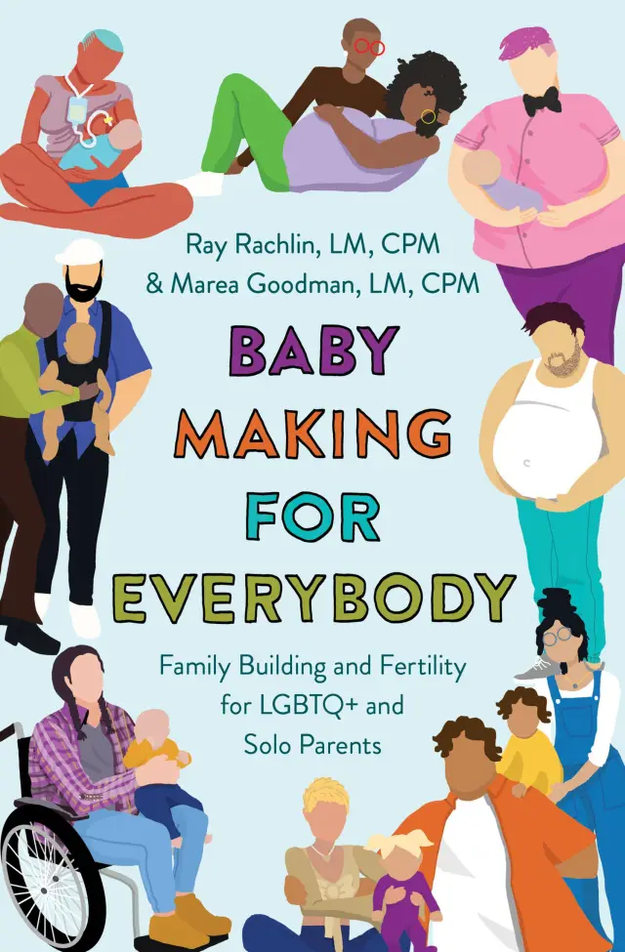
Baby Making for Everybody: Family Building and Fertility for LGBTQ+ and Solo Parents
by Marea Goodman and Ray Rachlin, LM, CPM
Queer midwives Marea and Ray share LGBTQ+ inclusive information on a variety of family building topics such as choosing sperm or egg donors, navigating pregnancy and gender identity, foster parenting and adoption, and miscarriage and infertility.
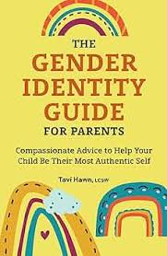
The Gender Identity Guide for Parents: Compassionate Advice to Help Your Child Be Their Most Authentic Self by Tavi Hawn, LCSW
All people develop a gender identity. Learn how to be an affirming parent and create a safe environment for your child as they approach puberty and explore their gender identity.
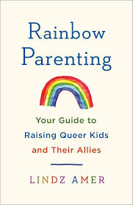
Rainbow Parenting: Your Guide to Raising Queer Kids and Their Allies
by Lindz Amer
“Whether the kids you are raising (or helping to raise) are queer, questioning, or straight/cisgender, and whether you know nothing about LGBTQ identities or are proudly queer yourself, this book will assist you in creating an environment where they and their peers can grow up affirmed and supported.” - Mombian.com
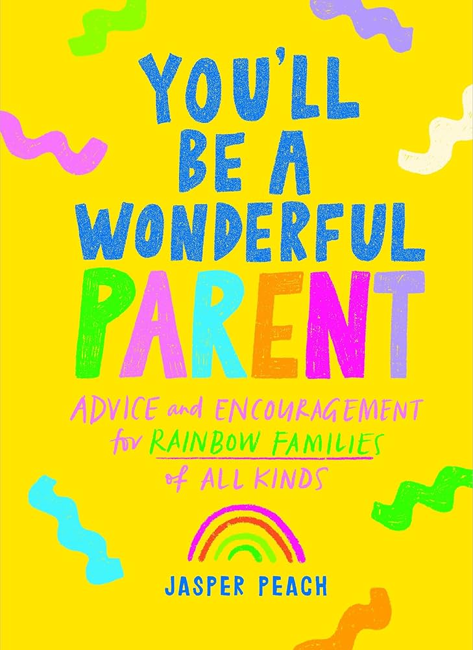
You'll Be a Wonderful Parent: Advice and Encouragement for Rainbow Families of All Kinds
by Jasper Peach
Encouraging and emotionally supportive in tone, this book is less of a how-to guide to LGBTQ+ parenting and more of a supportive and affirming friend cheering you on. Great for new families or for those who want to hear stories from an author who “gets it.”
Picture Books
Becoming Siblings by Shuli De La Fuente-Lau
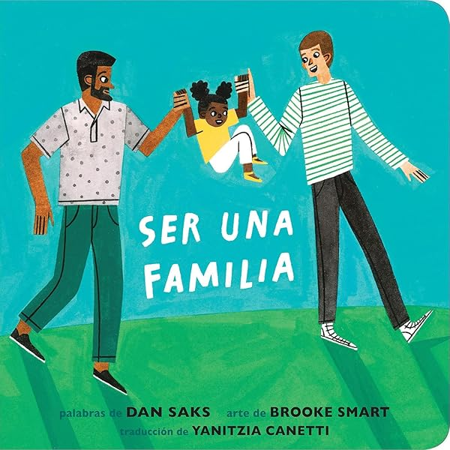
This board book features real photos of diverse families with rhyming text about preparing to welcome a new sibling. Part of a series.

Families Can / Ser Una Familia by Dan Saks and Brook Smart - also available in Spanish
This illustrated board book with rhyming text celebrates diversity by making it embedded in the everyday activities of the families. “A family can have two daddies or two moms. Any way you count it, there are big loving arms.”

Bodies Are Cool / Los cuerpos son geniales by Tyler Feder
A picture book that celebrates all kinds of bodies. Queer couples, transgender people, nonbinary people, and other LGBTQ folks are pictured, as well as people of all kinds of shapes, abilities, ages, and more.
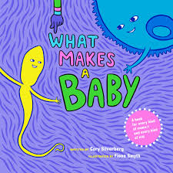
What Makes a Baby / ¿Cómo se hace un bebé? by Cory Silverberg and Fiona Smyth
A picture book that describes how babies are made in a kid friendly, anatomically factual, and queer-inclusive way. Great for early discussions about where babies come from.

