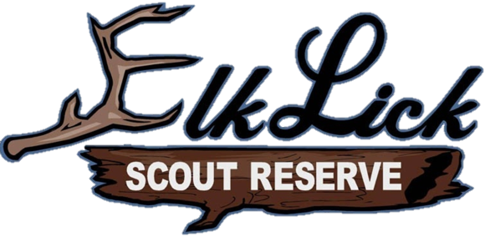 |  | Seasonal Camp Chaplain
Outline  During the summer the position provides religious guidance and in some cases counseling for children who may need it. To lead before meal prayers, provide general and specific religious ceremonies. We work with kids aged 5-11 and their adults. As an Elk Lick employee, you will be expected to help with set up and tear down of camp as well as setting up your own living space within camp.  Contact  To Apply:  Stephanie Johnston  716-573-4443  Elk Lick Camp Director  WEBSITE:  Elklick.org  Alleghenyhighlands.org  basic requirements  21 years or older  Must become a BSA Adult  Must do online trainings  Live on site for 6 weeks  Be able to lead in general and specific faith base  Elk Lick Scout Reserve  2420 Bordell rd.  Smethport PA |  | On- site requitements  BSA adult application, must be completed  Online trainings on myscouting.org (youth protection training, harassment, weather hazard training, and chaplain)  Be able to help set up and tear down a scout camp  Be able to lead meal prayer, Vespers, and help with cub scout duty to god belt loop. (outlined in each cub scout book that will be provided)  Be able to council children in a public-private way.  Basic contracted time  The necessary time needed at camp for the summer are July 1st though August 7th  There are staff gatherings that are required. May 10th-11th, May31st -June 2nd. These weeks help get to know fellow staff as well as your environment for the summer.  These are meant to be fun and constructive weekends to prepare you and your work area for the summer  Our Chaplain is given their own chapel to prepare, live in and utilize for the summer as they wish.  opportunity  The chance for growth is there. To work with such awesome kids as the Cub Scouts and help them have a great summer in various areas. If you are interested, please head to ELklick.org under employment select “other” and in explain add for Chaplain. If you may be interested in any other position at camp, we are now hiring across the board.

