FREE MENTAL HEALTH FIRST AID TRAINING!!!

Hello!
Catholic Charities is pleased to be able to offer a full day (8 hours) of Mental Health First Aid training, free of charge!
DETAILS: **** Training will be September 29th at Covenant Medical Center in Waterloo, IA. Lunch will be provided. REGISTER by emailing Teresa King at Teresa.King@dbqarch.org or by calling (319) 272-2080 Start time will be 8:00 AM. RSVP by 09/21/18. Please see training summary below for more information.
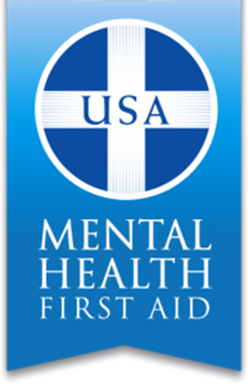
Mental Health First Aid USA is a public education program that introduces participants to risk factors and warning signs of mental health problems, builds understanding of their impact and overviews of appropriate supports. This 8-hour course uses roleplaying and simulations to demonstrate how to offer initial help in a mental health crisis and connect people to the appropriate professional, peer, social and self-help care. The program also teaches common risk factors and warning signs of specific illnesses like anxiety, depression, substance use, bipolar disorder, eating disorders and schizophrenia.
Mental Health First Aid teaches participants a five-step action plan, ALGEE, to support someone developing signs and symptoms of a mental illness or experiencing an emotional crisis:
- Assess for risk of suicide or harm
- Listen non-judgmentally
- Give reassurance and information
- Encourage appropriate professional help
- Encourage self-help and other support strategies

Like CPR, Mental Health First Aid prepares participants to interact with a person in crisis and connect the person with help. Aiders do not diagnose or provide any counseling or therapy. Instead, the program offers concrete tools and answers key questions like, “What do I do?” and, “Where can someone find help?”
Thank you so much,
Teresa King
Community Outreach Coordinator
Catholic Charities
2101 Kimball Avenue, Suite 138, Waterloo, IA 50702
319.272.2080
teresa.king@dbqarch.org

