The Center for Farmworker Families Holiday Gift Drive for Children

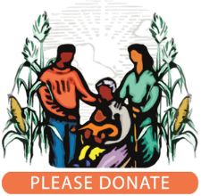
Thanks to those of you who have already signed up to provide a special holiday gift to the children of farmworker families in Santa Cruz County.
All gifts should be age-appropriate, gender-neutral, engaging, and approximately $50 in value. Gifts should be donated UNWRAPPED, in a bag or box. Gifts should be delivered to Peace United Church of Christ by Friday, December 4. For any questions, email Tony at pastmoderator@peaceunited.org.
Thank you!

Church members will be on hand after worship on Sunday November 1 with sign-up sheets and more information. For a complete description of the Center's holiday gift drive, view a short slide presentation by clicking HERE.
Some gift ideas:

🎨 Creative Kids | 🔬 STEM Explorer | 🎬 Movie Night
Coloring books or sketchbooks | STEM experiment kits | Movie gift card
Colored pencils or markers | Building sets | Blanket
Art kits | Small puzzles | Stuffed animals
Small craft projects | LEGO® sets | Popcorn and snacks
Creative activity kits | Engineering or science kits | Cozy movie-night accessories

You can also sign this form, scan or take a photo of it and return by email to pastmoderator@peaceunited.org

Yes, I/we will participate in the Center for Farmworker Families’ Holiday Gift Drive.

Contact Information
Name: Phone number: Email address:

