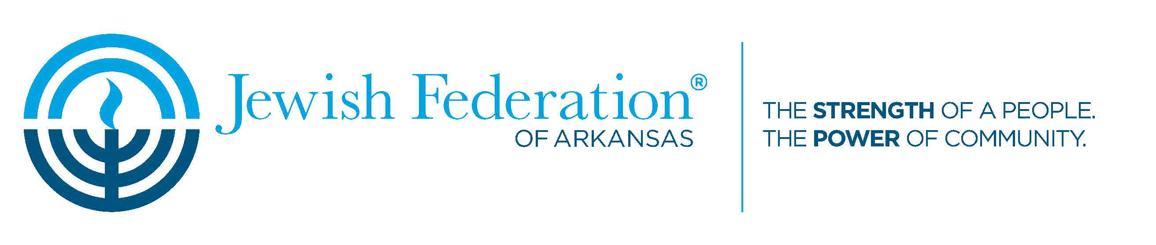
Religious/Cultural Booth Contract
2019 Jewish Food and Cultural Festival – Sunday, April 14th
Please return by Friday, March 15th, by e-mail to director@jewisharkansas.org or by post to 18 Corporate Hill Drive, Suite 204, Little Rock, AR 72205.
I. The purpose of this document is to establish the responsibilities of Jewish Federation of Arkansas (JFAR) and those of Jewish Religious and Cultural Organizations who will have a booth at the 2019 Jewish Food and Cultural Festival (Festival).
II. Responsibilities of JFAR:
A. JFAR agrees to provide two tables of 14 foot length in total, with both facing general public, and two chairs. JFAR will assign a location in advance to each Religious/Cultural Organization. Tables will be set up not later than 8:00 am for the Religious/Cultural Organization to begin arranging items and materials.
B. JFAR agrees to make every attempt to publicize the event, however attendance cannot be guaranteed.
III. Responsibilities of the Religious/Cultural Organization:
A. the Religious/Cultural Organization may have items available for demonstration or to give away, but the Religious/Cultural Organization will not sell any items at the Festival.
B.. The Religious/Cultural Organization agrees to indemnify and hold harmless, the Jewish Federation of Arkansas, its officers, agents, employees, or guests from and against any and all claims, demands, loss or liability of every nature, for theft, weather damage, or injuries to persons and/or property, occurring in or about or in any way connected with the festival event.

Signed _______________________________________ Date____________
(Jewish Federation of Arkansas)

Signed _______________________________________ Date____________
(Religious/Cultural Organization Representative)

