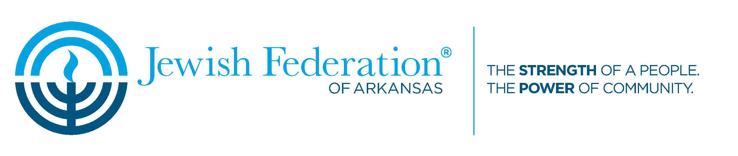
Vendor Contract
2019 Jewish Food and Cultural Festival – Sunday, April 14th
Please return by Friday, March 15th, by e-mail to director@jewisharkansas.org or by post to 18 Corporate Hill Drive, Suite 204, Little Rock, AR 72205.
I. The purpose of this document is to establish the responsibilities of Jewish Federation of Arkansas (JFAR) and those of vendors who are using a booth at the 2019 Jewish Food and Cultural Festival (Festival).
II. Responsibilities of JFAR:
A. JFAR agrees to provide two tables of 14 foot length in total, with both facing general public, and two chairs. JFAR will assign a location in advance to each vendor.
B. JFAR agrees to make every attempt to publicize the event, however attendance cannot be guaranteed.
III. Responsibilities of the vendor.
A. The Vendor agrees to provide items for sale at booth during the festival hours of 9:00 am to 4:00 pm on April 14th, 2019, or until the vendor’s supplies run out. Tables will be set up not later than 8:00 am for the Vendor to begin arranging items for sale.
B. The Vendor agrees to provide 20% of all sales to Jewish Federation of Arkansas.
C. The Vendor agrees to remit sales tax to the state of Arkansas in the amount of 9% of gross sales and to fill out the “Special Events Sales Daly Tax Report Schedule” form (to be provided prior to the Festival).
D. The Vendor agrees to indemnify and hold harmless, the Jewish Federation of Arkansas., its officers, agents, employees, or guests from and against any and all claims, demands, loss or liability of every nature, for theft, weather damage, or injuries to persons and/or property, occurring in or about or in any way connected with the festival event.

Signed _______________________________________ Date____________
(Jewish Federation of Arkansas)
Signed _______________________________________ Date____________
(Vendor)

