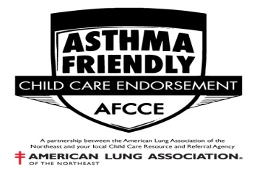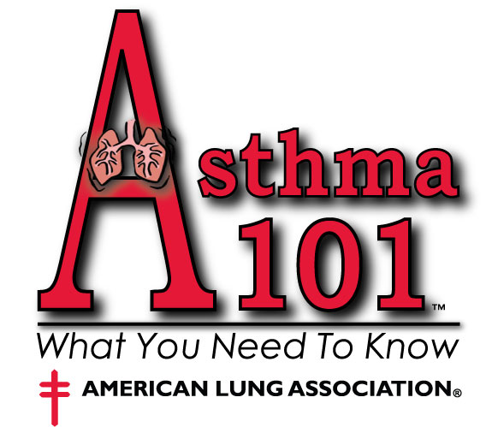

Asthma Friendly Child Care Endorsement Application

Name: ___________________________________________________ Date: ______________________

Program Information

Name: ______________________________________________________________________________________________________

Site Address: __________________________________________ Mailing Address: ___________________________________

City / State / Zip: _______________________________________ City / State / Zip: ___________________________________

Main Office Phone #: ____________________________________ Site Phone #: _______________________________________

Fax#: _______________________ Email: _______________________________ Website: ________________________________

Modality: (Check one & enter information)
Family Child Care Provider Group Family Child Care Provider Child Care Center School Age Child Care Program

_______________________ _______________________ ___________________________
License / Registration # License / Registration Expiration Date Name of Licensor / Registrar

Fee schedule: (Please check one according to modality & HCC Service Program Status)
• All fees are to be submitted with completed application and are non-refundable.

Programs on HCC Service Programs not on HCC Service
Family Child Care Provider - $15 Family Child Care Provider - $30
Group Family Child Care Provider - $20 Group Family Child Care Provider - $40
Child Care Center - $50 Child Care Center - $100
School Age Program - $50 School Age Program - $100

My signature indicates that I:
- Have read, understand, and agree to the responsibilities of the Endorsement Process as per AFCCE Informational Sheet
- Have verified that the information submitted on the Asthma Friendly Endorsement Guide is true to the best of my knowledge.

____________________________ ____________________________________ ___________________
Applicant’s Name (Printed) Signature Date

Asthma Friendly Child Care Endorsement Guide

Y | N | ? | # | Asthma Management
 |  |  |  | A staff member who has attended an accepted training course on asthma management which includes general information, environmental control measures, medication, asthma triggers avoidance planning, and asthma emergency management is on-site whenever a child with asthma is present.
 |  |  |  | We have and maintain current training on asthma care requirements (at a minimum of every two years)
We have an individualized Asthma Action Plan for each child with asthma enrolled in our program.
The program will review the Asthma Action Plan with all staff involved with the child’s care and staff authorized to administer medication. REQUIRED
 |  |  |  | We review each child’s emergency Asthma Action Plan at least annually to ensure that we are ready and able to care for that child and the others in our care in the event of an emergency.
 |  |  |  | The Blue Card / Emergency contact information will be obtained and reviewed at the time of admission & will be updated when a change occurs and at least every six months. We review our emergency contact information and ‘permission to treat’ at least every six months for each enrolled child with asthma. REQUIRED
The program will review the Asthma Action Plan with all staff involved with the child’s care and all staff authorized to administer medication.
We have a procedure to notify all staff of all children who have asthma.
 |  |  |  | We have an asthma travel pack for all outings which includes the student’s quick relief medications, medication instructions and consent, emergency contact information and permission to treat, and means of communication for emergencies that is carried by an adult who is trained in asthma management and medication administration.
 |  |  |  | Medication Administration
 |  |  |  | We are legally able to administer medication to children with asthma in our program. REQUIRED
Medication is stored in a manner that is inaccessible to children yet readily accessible to adults who are trained to administer medications.
All medication will be kept in the original labeled container REQUIRED
 |  |  |  | Medication is labeled with the child’s first and last name and has corresponding health care provider instructions and parental consent in writing. REQUIRED
We periodically review the medication and medication administration instructions to ensure that we are ready and able to follow the child’s emergency medication plan.
Medication expiration dates will be checked on a monthly basis. Parents will be informed regarding the need to replace the medication before it expires.
 |  |  |  | Education and Awareness
 |  |  |  | We create opportunities to educate the families we serve on asthma friendly practices.
 |  |  |  | We will provide educational programming for all children about asthma.
 |  |  |  | Asthma Friendly Facility
 |  |  |  | Air Quality
 |  |  |  | We avoid conditions that lead to excess moisture because moisture contributes to the growth of mold and mildew. We maintain adequate ventilation. We repair water leaks. We keep humidity in the desirable range of 30-50%.
 |  |  |  | We do not allow cars or other vehicles to idle in our parking areas.
 |  |  |  | We do not use scented or unscented candles or manufactured air fresheners.
 |  |  |  | We do not permit smoking anywhere on the premises or in sight of children. REQUIRED
 |  |  |  | If staff smokes in clothes that they will wear for work, we have a policy requiring the use of a smoking jacket to reduce lung irritants on their clothes.
 |  |  |  | We keep garbage covered at all times to avoid attracting pests and to minimize odors.
 |  |  |  | Household Chemicals
 |  |  |  | We use chlorine bleach mixed to the lowest effective concentration appropriate to the surface. We use the appropriate amount and never when children are nearby.
 |  |  |  | We do not use aerosol sprays of any kind.
 |  |  |  | Pest Prevention
 |  |  |  | We use non-toxic techniques both inside and outside the facility to control pests. If pesticide application is required to address a serious threat parents are notified in advance and a licensed professional is used to apply the least toxic, most effective product at a time when children will not be exposed. REQUIRED

