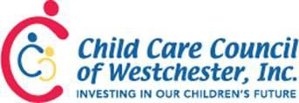

Asthma 101: What You Need To Know Registration Form

PAYMENT MUST BE INCLUDED

Name of Program:

Address of Program:

Program Contact Person:

Program Phone: Email:

Date Time Code
Tuesday, January 24, 2017 9:30 am – 12 pm 70124

Cost: $10 per person for Programs on HCC Service
$20 per person for Programs not on HCC Service

Are you on the Child Care Council Health Care Consultant Service: □ Yes □ No
Please list the participant’s name and program address (for programs with more than one site):

Name: Address:

Name: Address:

Name: Address:

Name: Address:

Total # of Participants Attending: Total Enclosed:

Method of payment: (Check One)
- Check / Money Order made payable to Child Care Council of Westchester, Inc.
- Credit card: Visa / Master Card/ Amex (Please circle one)
Name as it appears on credit card: _

Billing address (include zip code):

Credit card #: Expiration date:

Signature: Date:

To register, contact Juliana Leshi at 761-3456 ext. 111 or julianaleshi@cccwny.org

