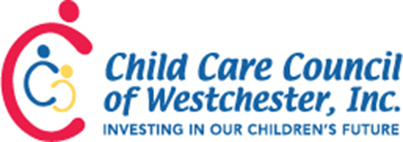

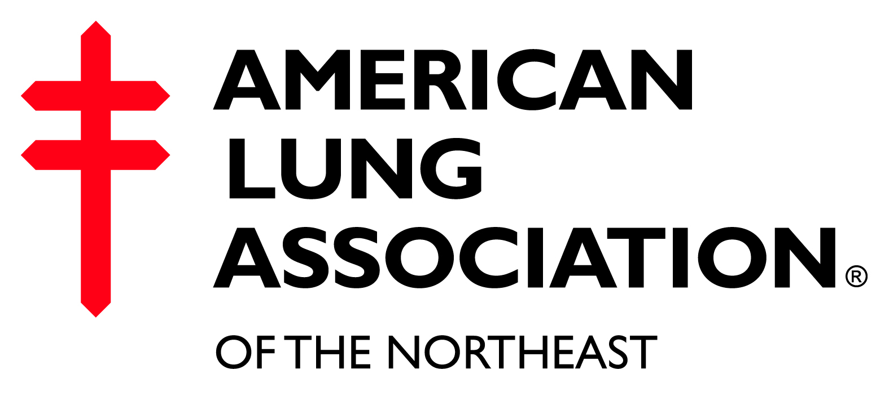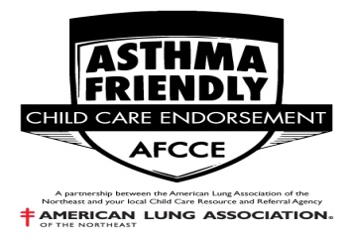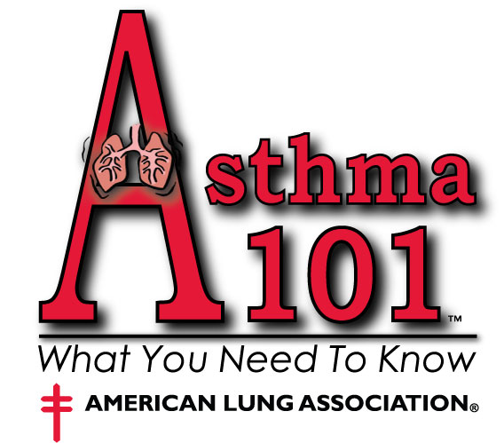

Asthma Friendly Child Care Endorsement Informational Sheet
The Child Care Council of Westchester has partnered with the American Lung Association of New York to develop a pilot project directed at creating the safest environment for children with asthma.
The overall goal of the Asthma Friendly Child Care Endorsement Initiative is to raise awareness, educate, train and support child care programs in order for them to provide healthier and safer child care environments for children with asthma.
There will be a limited number of programs accepted to become an endorsed asthma friendly child care program during this introductory period. Programs accepted during the first round will receive special pricing. For pricing information, refer to the application or call the the Health Care Consultant Services Department.

Why Should I Become an Asthma Friendly Endorsed Child Care Program

- Increase your marketability
- Learn how to recognize and manage asthma symptoms
- Learn how to create asthma-friendly environments by identifying and reducing asthma triggers
- Understand the importance of an Asthma Action Plan
- Learn how to appropriately respond to breathing emergencies
- Receive training hours covering four (4) topic areas - Nutrition & Health Needs of Children, Safety & Security Procedures, Statues & Regulations Pertaining to Child Day Care, and Business Record Maintenance
- Access to various asthma resources that may also be shared with parents
- Receive an endorsement certificate & window decal
- The Council’s Resource & Referral Database Profile will include you as an Asthma Friendly Program
- Receive education, support, and on-going technical assistance from the Council’s Health Care Consultant
- Assistance in developing clear easy-to-follow policies and procedures for children with asthma
- Parents will feel at ease knowing that their child is in an Asthma Friendly Environment

Endorsement Process

- Attend “Asthma 101: What You Need To Know” Workshop – check our website for dates or call

- Complete the Asthma Friendly Child Care Endorsement Guide (answer all 22 items) – guide provided after attending Asthma 101 Workshop

- Complete the Asthma Friendly Child Care Endorsement Application – available on our website and also provided at the Asthma 101 Workshop

- Mail / Submit the completed Asthma Friendly Child Care Endorsement Guide, Application, and
Payment (pricing information is noted on aplication) to:

Asthma Friendly Child Care Endorsement
Child Care Council of Westchester, Inc.
313 Central Park Ave.
Scarsdale, NY 10583

- Health Care Consultant will review and score the submitted Asthma Friendly Child Care Endorsement Guide. A passing score is 17 out of 22.

- Health Care Consultant will schedule a site visit. The site visit will cover:
- Review of the submitted Asthma Friendly Child Care Endorsement Guide
- Review of Indoor Air Quality Checklist
- Review of Asthma Action Plans & Medication Consent Forms
- Visual inspection of program which will include a humidity & moisture check
- Review of any needed recommendations and plan for improvements.
The plan for improvements will include an agreed upon timeline
- Follow-up by Health Care Consultant. Type of follow-up will be based upon plan.

- Official Program Endorsement
- After the above steps are completed, program will receive:
- Asthma Friendly Child Care Endorsement Certificate to display
- Asthma Friendly Child Care Endorsement window decal to display in entry way
- Your program will be listed as an Asthma Friendly Program; the Council will educate parents about the endorsement

- Renewal
- Endorsement is valid for two years
- Renewal process will begin 2 months prior to Asthma Friendly Child Care Endorsement Certificate expiration date.

We are very excited about this new initiative which will allow programs to be identified as a safe and healthy place for children with asthma. For more information, call the Health Services Department at 761-3456 ext. 154. We look forward to speaking with you about becoming an Asthma Friendly endorsed program.

