
Membership Goal = 2 memberships from each family

JOIN ONLINE at https://jointotem.com/ca/redondo-beach/jefferson-elem/join
$15 = one member, one card, one vote.
($9.75 of your membership dues stays at Jefferson; $5.25 goes to the National, State and Local PTA)


Why join the PTA?
- A portion of your PTA membership along with a variety of PTA fundraising efforts throughout the year, allows us to make our already amazing school even better.
- We may not be on campus for the first part of the school year, but your membership helps us support a variety of educational programs for our children in a creative new way.
- The PTA connects families and schools so we encourage all parents, guardians, relatives, staff, and other adults to sign up.
- By joining the PTA, you show your children that school matters and that you are invested in their school. Without your membership and donations, educational programs will be significantly reduced.
- Membership dues are 100% tax deductible (TAX ID 95-6204301).
- Joining the PTA means you support our mission but DOES NOT commit you to volunteer for anything.
Join today and continue to support our wonderful school programs!
Classes with 100% Membership by November 4th will receive a prize.

JOIN ONLINE: https://jointotem.com/ca/redondo-beach/jefferson-elem/join
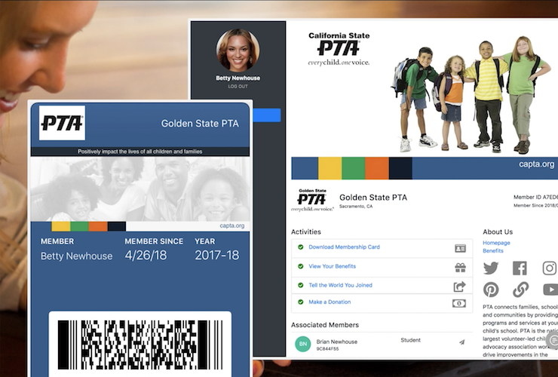
THE BENEFITS OF SIGNING UP ONLINE ARE:
- Secure, online signup with Credit Card or Mobile Pay.
- You will receive Smartphone Membership Cards
- Self-management of communication and payment preferences
- Downloadable end-of-year tax documents
- Ability to self-renew every year
- You can add as many memberships as desired to the same account (for example: memberships for both parents, kids, grandparents, etc.)
- Signing up online is easy and takes less time than writing a check.

Join OFFLINE: If you prefer to sign up for a PTA membership the traditional way, fill out the membership form on the back and drop off in the secure lock box next to the Jefferson office together with a check payable to Jefferson PTA. DO NOT combine with Emergency Kit or Spirit Wear payments.

Got a Question? Send an email to: JeffElem.PTA@gmail.com

Member Information:

Name: ___________________________________________ Email: ____________________________________
Circle one: Parent Grandparent Student Teacher

Name: ___________________________________________ Email: ____________________________________
Circle one: Parent Grandparent Student Teacher

Name: ___________________________________________ Email: ____________________________________
Circle one: Parent Grandparent Student Teacher

Name: ___________________________________________ Email: ____________________________________
Circle one: Parent Grandparent Student Teacher

Name: ___________________________________________ Email: ____________________________________
Circle one: Parent Grandparent Student Teacher

Child’s(Children’s) name(s), Teacher, and Grade for the 2022-2023 School Year:

Name: ___________________________________________ Teacher:___________________Grade:__________

Name: ___________________________________________ Teacher:___________________Grade:__________

Name: ___________________________________________ Teacher:___________________Grade:__________

Membership summary:
Number of PTA memberships ________ x $15 = $________________________
Additional donation $___________



