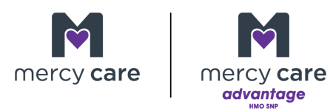

AHCCCS System Updates

Date of Notification: 04.16.2026
Code T2033
Effective March 1, 2025, the modifier TG (Complex/High Tech Lev) with POS 13 (Assisted Living Facility) has been added to code T2033 (Residential Care, Not Otherwise Specified (NOS), Waiver).

