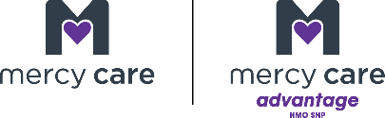

2025 Mercy Care Advantage Model of Care Training and Attestation

This is an important reminder about your contractual responsibility to complete your Model of Care (MOC) Attestation in a timely manner.

The MOC for the MCA Special Needs Plan (SNP) offers an integrated care management program with enhanced assessment and management for enrolled dual eligible enrollees. The processes, oversight committees, provider management, care management, and coordination efforts applied to address enrollee needs result in a comprehensive and integrated model of care.
﻿

Dual Eligible Special Needs Plan MOC Training
Under our Medicare contract, we are required to implement a MOC and must provide ongoing training to health plan staff, network providers, out-of-network providers, and provider staff who contribute to the effectiveness of the MOC. The MCA MOC training provides education on the elements and goals established by the health plan and the role that our network providers and out-of-network providers play in its delivery to members. Providers are defined as those who treat and see members regularly – physical and mental health physicians, specialists, ancillary, organizations, care coordinators, administrative, and support staff.

Network providers are required to complete the MOC Training and submit an attestation within 90 days of contracting and annually thereafter, on or before December 31st of every year. Network providers can access the MCA MOC training and attestation with the following link: 2025 MCA Model of Care Training and Attestation. The training includes an attestation that must be completed by either network provider group or individual practitioner. Please note, if a group has completed the annual training and submitted an attestation, all practitioners hired after completion of the group attestation, must complete the training and attestation within 90 days of their hire date. In addition, Network Management Representatives can provide a copy of the MCA MOC training to network providers who prefer to conduct in office or virtual training for their staff. Network Management Representatives monitor timely MOC training completion and will follow up with network providers as required to comply with this MCA contract requirement.

﻿

