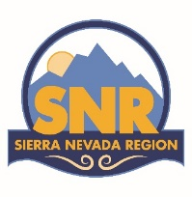
Call to District 1
Winter Leadership Summit
“Inspiring Transformational Leadership”

To: District 1 Members, Potential Members, SNR Region Governor, SNR Region Board Members, Committee Chairs and Representatives, SNR Federation Chairs and SNR Past Governors.
From: Teresa Armstrong, District 1 Director

What: Soroptimist District 1 members and their guests will gather to learn and share ideas together on developing leadership skills & goals.

Host Club SI Downtown Redding

When: Saturday, January 31, 2026
Time: 9:30 am-2:00pm. Registration starts at 9:30, meeting is 10 am- 2:00 pm

Where: St. James Lutheran Church, 2500 Shasta View Drive, Redding, CA 96002

Costs: $ 30 .00, lunch included.

Registration Link: https://registration.soroptimistsnr.org/events/2026-d1-wdm/ Registration deadline: January, 24, 2026.

Friday Night : No host Food, Drinks and Painting. Location: Market Street Blade & Barrel restaurant, 1777 Market St, Redding, CA 96001 (530)241-1777, Painting class cost: $30.00, to be paid at the door. No host food & drink off the menu.

Attire: Soropti-wear or casual attire.

Hotels: Hilton Garden Inn, 5050 Bechelli lane, Redding, CA 96002 (530)226-5111.

Donations: Please consider bringing a donation of feminine hygiene products to be donated to the Shasta County Women’s shelter “One Safe Place”

