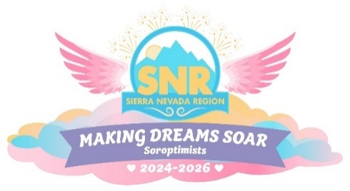
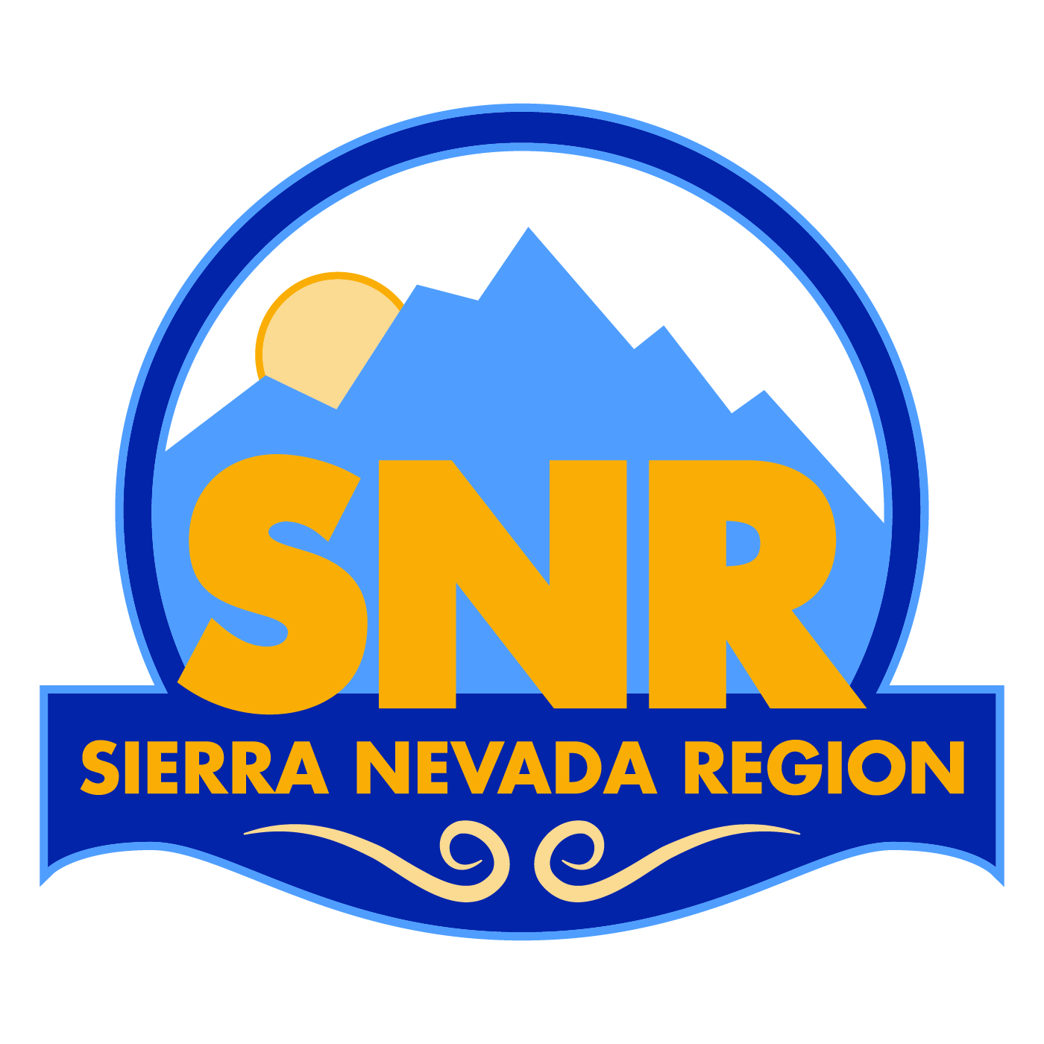

Official Call to District 3 Winter Leadership Roundtable
MARCH 1, 2025
To: District 3 Club Presidents, Vice Presidents, President-Elects, and Officers

From: Sheryl Longsworth, District 3 Director

When: Saturday, March 1, 2025. Registration opens at 9:15. Meeting is 9:30 am to 12 pm

Where: Rancho Cordova City Hall Boardroom, 2725 Prospect Park Dr, Rancho Cordova, 95670

Theme: “UpliftHER with Civility”

Cost: $15, includes continental breakfast

Optional lunch afterward: At the brand new and delicious woman-owned Stick & Roll Vietnamese Street Food Restaurant in the new SF Market Food Court, 2738 Sunrise Blvd, Rancho Cordova

Registration Link: https://registration.soroptimistsnr.org/events/2025-d3-winter/

