LHS Speech and Debate

Congratulations to the following students for qualifying for the NSDA National Championship to be held in Albuquerque, NM this summer!

Dramatic Interpretation: Luke Wheatley
Program of Oral Interpretation: Garrett Beckman
Original Oratory: Ryan Wang
PF: Kendall Carll and Shalin Mehta
LD: Kaya Czyz
CX: Andrew Mao and Tajvir Singh

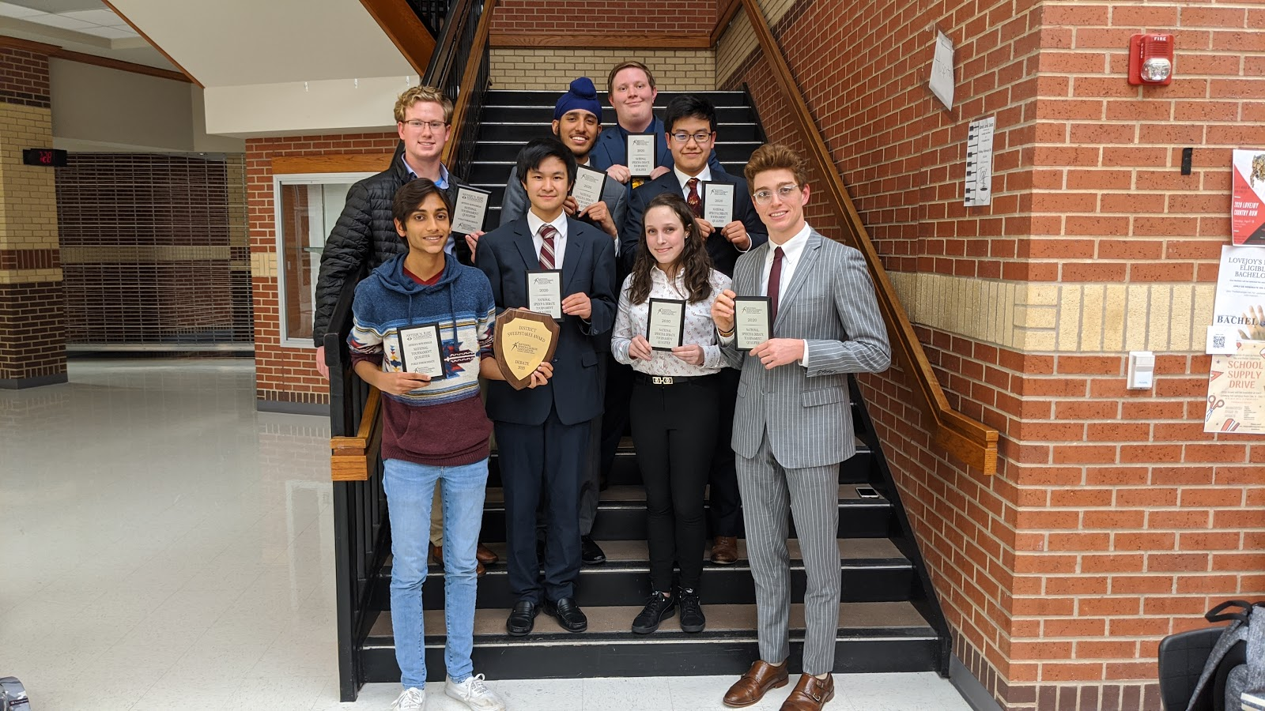
From right to left: Top row: Garrett Beckman; Middle row: Kendall Carll, Tajvir Singh, Ryan Wang; Bottom Row: Shalin Mehta, Andrew Mao, Kaya Czyz, Luke Wheatley

