Girls Soccer Win on Senior Night

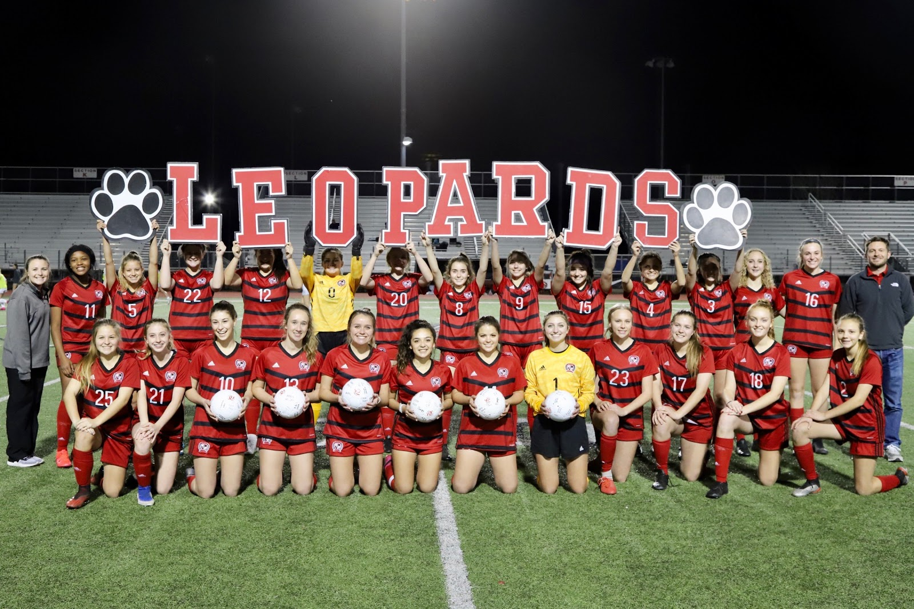

Friday night the Varsity girls soccer team beat Denison 3-0 on Senior Night. Senior Madison Quiroga scored the winning goal for the Leopards and provided an assist. Senior Reagan Matacale provided the assist for Katie Welch who scored the second goal. Hannah Dunlap secured the victory for the Leopards with the third and final goal. Hailey Downing and Senior Kamri McKnight were in goal to secure the clean sheet for the Leopards. The team is now 12-6 overall and 5-2 in district, just 3 points behind 1st place. Next game is in Sherman on Tuesday, March 3rd, at 7:15. Thank you to all the fans and the parents for your support on Friday night.

