HART ELEMENTARY
To line-up for car pickup, use Creek View Lane and lineup on Honeysuckle Lane.
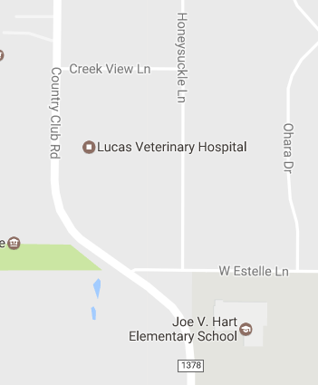
Please help us all to stay safe.
DO NOT use Estelle Lane to access Honeysuckle Lane
DO NOT turn left from Estelle Lane onto Honeysuckle Lane
DO NOT turn right from Estelle Lane onto Honeysuckle Lane
Please respect the homeowner’s property on Honeysuckle Lane:
DO NOT turn around in someone’s driveway
DO NOT block someone’s driveway
DO NOT park in the grass along Honeysuckle Lane
NO Right Turns
NO Left Turns

HART ELEMENTARY
To line-up for car pickup, use Creek View Lane and lineup on Honeysuckle Lane.
Please help us all to stay safe.
DO NOT use Estelle Lane to access Honeysuckle Lane
DO NOT turn left from Estelle Lane onto Honeysuckle Lane
DO NOT turn right from Estelle Lane onto Honeysuckle Lane
Please respect the homeowner’s property on Honeysuckle Lane:
DO NOT turn around in someone’s driveway
DO NOT block someone’s driveway
DO NOT park in the grass along Honeysuckle Lane
NO Right Turns
NO Left Turns

