Leopard Bowling

Our Men’s Varsity team competed at the Regional Tournament this past weekend against 8 other teams from the region, including Allen HS and Plano Senior HS. With a record of 7 wins and 1 loss, the men placed 2nd and earned a trip to the State Championship in San Antonio. We are very proud of these young men!!!

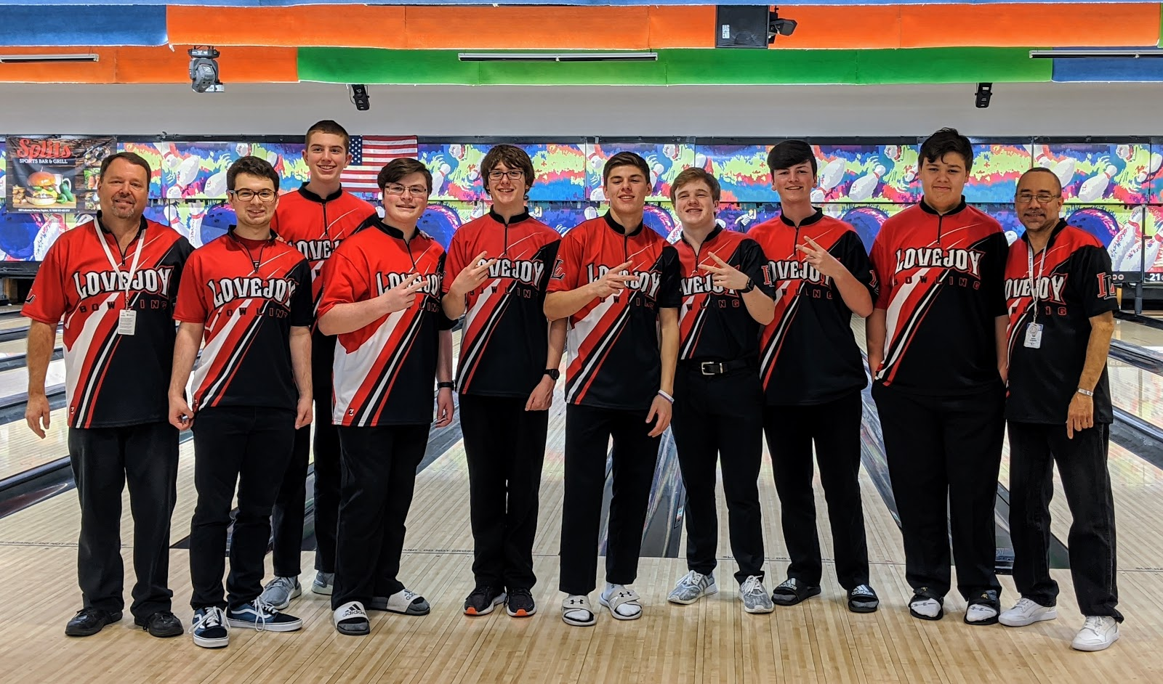

Pictured from left to right: Coach David Smith, Senior Matthew Poteet, Freshman Fletcher Boots, Sophomore Wynston Falk, Junior JR Frazier, Senior Mason Melendez, Senior Noah Cooper, Sophomore Garrett Falk, Freshman Jack Melendez, Coach Mickie Tate

We also had a few bowlers qualify for the Regional Tournament as individual bowlers.

Senior Noah Cooper placed 2nd at this year’s Regional Tournament, advancing him to the State Championship. Sophomore Garrett Falk placed 13th at this year’s Regional Tournament.

Both gentlemen bowled their hearts out as they competed to advance to the State Championship.
We are beyond proud of them!!
