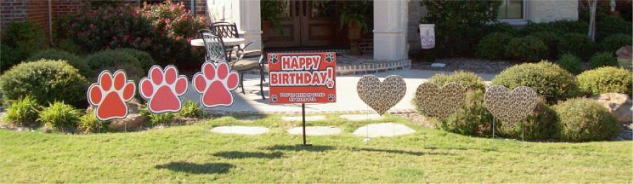

Date of special occasion: _____________________________________________________________
Name of person placing order: ______________________________________________________ phone # (for order confirmation): __________________________________________________ Method of Payment: Cash _____Check (made out to Hart PTA)________________________________
Signs to be delivered to: _____________________________________________________________
Name of person receiving signs: ____________________________________________________
Address to be delivered to: __________________________________________________________

Please select one option. The cost is $25:
________”Happy Birthday” , paw signs, leopard print heart signs
________”Happy Birthday”, paw signs
________”Happy Birthday”, leopard print heart signs
_________”We are proud of You”, paw signs, leopard print heart signs
_________”We are proud of You”, paw signs
_________”We are proud of You”, leopard print heart signs

*Please note signs can be placed during daylight hours the day before (depending on availability of schedule). If you would like to have signs placed on porch/driveway/garage we can do so and you can put them out that evening. Please text or email Nicki York (214-704-9805/nyork923@yahoo.com) with specific instructions.

Please send completed order form with payment to school or mail to:

Nicki York
599 Bastrop Rd
Lucas, TX 75002

Please allow 48 hours for order and payment to be received. .
Thanks so much for supporting Hart PTA!

