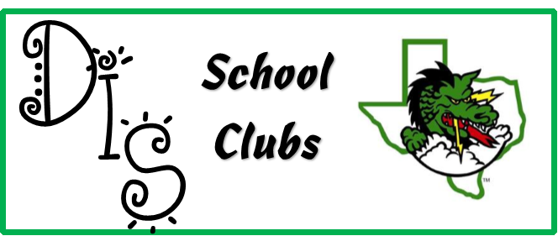
DIS Ambassadors
Teachers: VanBreemen, Jarvis, Luther, Snow, Johnsen, Mangham
Sign up - new members later this fall (announcements will be made)
When - Meets on Tuesdays before school (once a month for most)
Where - Ambassador Room
Other - There will be an application.
More information: Laurance.Mangham@southlakecarroll.edu

Newspaper Club
Teacher – Giffin
Sign up - Applications available in Mrs. Giffin's room - E106. Complete and return application with parent signature on or before September 22, 2017.
When - Club will meet Tuesday and Thursday mornings, beginning October 3rd.
Where – E106
Other - 5th and 6th graders are welcome to apply. We will need reporters, cartoonists, interviewers, and layout specialists.
More information: Marti.Giffin@southlakecarroll.edu

Animal Club
Teacher – Johnson & Oliver
Sign up - Teachers Canvas Page. Students must have permission to sign up for one 9 week period.
When - Tuesday & Thursday mornings from 8 – 8:25. A pass will be given to the students so they can get in the hall at that time.
Where – I100 & I101
Other - The DIS Animal Club offers students the opportunity to learn how to care for the animals in the Science Lab. Students who participate in the club will be taught how to clean out the cages, handle the animals, feed and care for the animals.
More information: Wendy.Oliver@southlakecarroll.edu or Dena.Johnson@southlakecarroll.edu

Quidditch club
Teacher – DeRaud
Sign up – Coming Soon
When –
Where –
Other –
More Information: Sara.Deraud@southlakecarroll.edu

UTUBE Club
Teacher - Winnard
Sign up – Coming Soon
When –
Where –
Other –
More Information: Jennifer.Winnard@southlakecarroll.edu

Mixed Choir
Teacher - Gillum
Sign up - http://tinyurl.com/DurhamChoir17-18
When - 3:50-4:45pm Rehearsals are Mondays after school
Where: DIS Music Room
Requirements: Anyone who loves to sing!
More Information: Amanda.Gillum@southlakecarroll.edu

Book Club
Teacher - Green
Sign up – In the Library
When – Thursday mornings 8-8:30am beginning October 5th
Where – Library
Other –
More Information: Jennifer.Winnard@southlakecarroll.edu

Art Club
Teacher - Bruns
Sign up – Complete Permission Slip - Art Room G101
When – See member dates
Where – Art Room G101
Other – 2 different Art Clubs that will meet once a month until the end of school. Students may join one of the clubs offered.
More Information: DIS art website, Mr. Bruns Twitter (@BrunsArt)

