Sense of Touch Activity
Gather your materials. You will need a wipes container that has a rubbery opening (a kleenex box works well too), soft items like cotton balls, feathers, small pieces of fleece, and harder objects like blocks, keys and toy cars. Pop the outer lid off the box so it doesn’t scratch your little ones arm when they reach in.
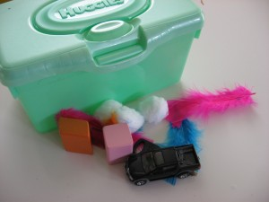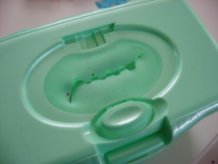
Add the items to the box. Invite your child to reach in and find something hard. Start a pile for the hard items. Feel for something soft and sort in a pile for soft items. Continue sorting until all the objects are out of the box.

