How to Grow a Bean in-a-Jar

Materials
- An empty jar
- Cotton balls
- A dry bean
- Water & a sunny window
Note: We used a Lima bean, but any dry bean should work.

Method
- Begin by wetting several cotton balls and placing them into a jar. You want the cotton balls to be wet but not too saturated.
- Wedge a bean between the cotton balls and the glass of the jar so that your child can easily observe the bean growing
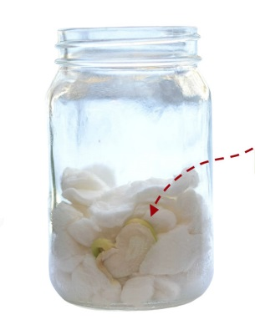It is now time to watch & observe.
- Have your child predict what will happen to the bean, and then observe the jar over the next several days.
- Add a few drops of water to the cotton balls as needed.

Bean in-a-Jar Experiment
- The bean will begin to change fairly quickly. Our beanstalk began to form after just 1 day. This is what our bean looked like after 3 days.

