PHONICS: LETTERS MM, SS, TT, RR, NN, AND PP REVIEW
Students can review previously introduced letters by doing a letter/initial sound sort. This is an easy and quick way to informally assess a child’s knowledge of letter sounds and if they can differentiate various initial sounds to match with the appropriate letter. Below is an example of some of the photos the children can sort.
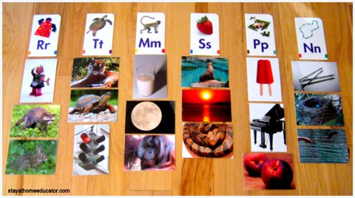

If a child seems to struggle with where to put a photo, try a dialogue like the following:
Adult: What is the name of your card?
Child: Piano.
Adult: What sound to you hear at the beginning of piano?
Child: /p/, /p/, /p/
Adult: Good! What letter makes the sound /p/?

