Sticky Notes Name Graph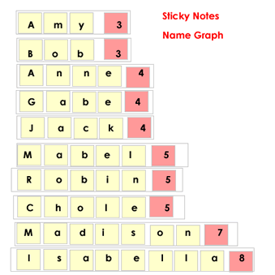

Although this takes lots of sticky notes the children become more aware of how their name is composed of letters and have an opportunity to count how many letters in each name.

Materials:
- chart paper
- tape
- small size sticky notes in 2 colors
- felt markers
- strips of card to tape the notes onto

Procedure:
Students…
- Take a strip of card and some sticky notes
- Print one letter of their name on each sticky note, then stick it to their card
- Arrange the letters on their strip of card
- Add one of the second color sticky notes
- Count how many letters in their name
- Record the number on the second color sticky note
- add their name card to the chart paper
- You may want to secure the sticky notes to the cards with tape, so they can be rearranged for other activities without the notes dropping off.

As a group:
- How can we sort or rearrange the names?
- Is there a different way we can sort or rearrange the names?
- Ask – how many names all together, how many numbers all together, how many boys’ names, how many girls’ names
- Are there fewer (or more) names with 7 letters? 5 letters etc.

Use the name graph above to teach letters and letter sounds
- Rearrange the children’s names by beginning sounds
- Count how many begin with an A or B, etc.
- Show the children a letter and have a few children a day try to find the letter in the chart using a pointer

