Self Portrait

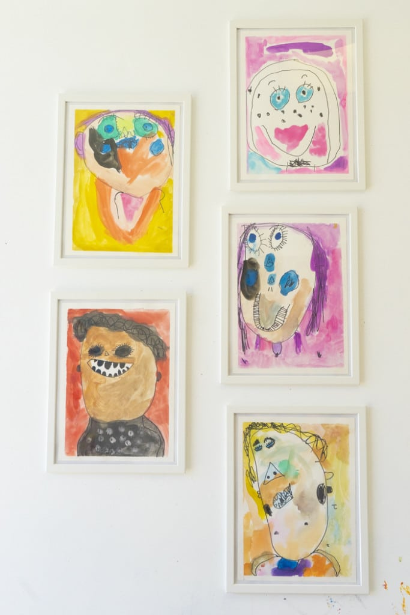
This is the perfect activity…all you need is a Sharpie, watercolor paints, paper and you! Once the permanent marker outline is down, you can paint over with the watercolor and let the colors flow! I love the idea of doing these at least once a year to see how kids’ self-image changes.

