Nature bottles
Save a plastic water/ drink bottle next time you have finished with it and create the easiest little activity for your little adventurers.
Put some water inside the bottle and take it out into the garden, to the park or wherever you would like to go and explore with your little one.
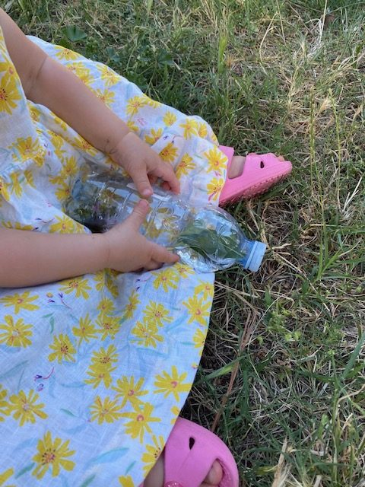
As we all know very well by now, our toddlers want to pick up everything and anything they see when they are out- particularly the things they shouldn’t.
Encourage them to collect some leaves, flowers, stones, grass….the list goes on.
Start by example and put each collected item into the bottle with water and watch it swish around.
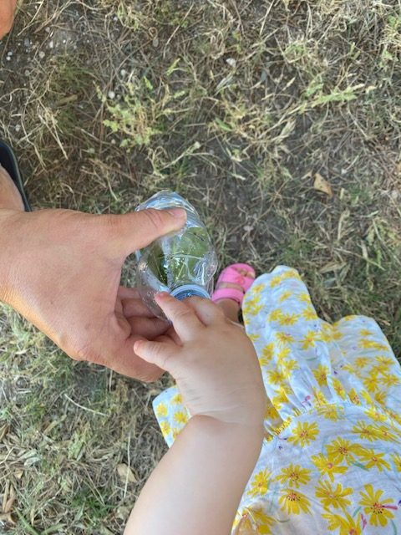
Our little ones at this age are suckers for information and love copying what we do so it is the perfect chance to for them to follow our lead.
This activity is also brilliant as it allows our little munchkins to concentrate on pushing the items through the small hole of the bottle.

