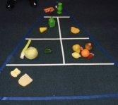
Food Pyramid
Teach your preschoolers about nutrition by introducing the food pyramid.
In advance, make a large pyramid. The top triangle is for "Fats" (butter, sugar, etc.); the next row is cut into 2 equal parts (1 for dairy and one for protein--remember that eggs go with protein not dairy!);
The next row is also in 2 equal parts- 1 for fruits and one for vegetables; and the bottom row is for Grains (breads, pasta, cereal, crackers, rice).
Explain that we need foods from each of the food groups to stay healthy.
Provide pictures of foods from magazines and ask them to place them in the food pyramid chart where it belongs.
VARIATION: The picture above of a Food Pyramid made for circle time! Give each of the children some play food. After discussing the pyramid, they each take a turn identifying their food and where it would go on the pyramid and then placed it there!

