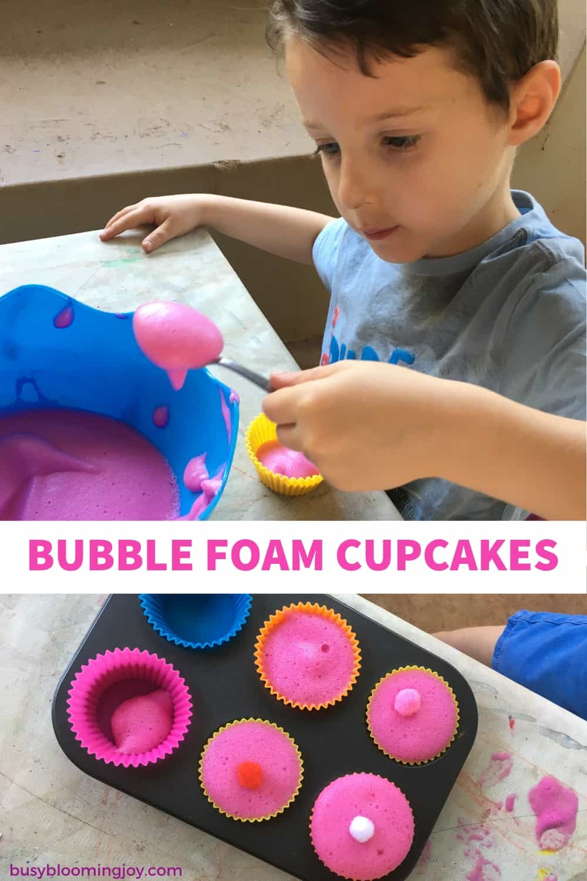

#13 Bubble foam cupcakes
Activity supply list: bubble bath, food coloring, water, electric whisk, muffin tins, pompoms,
Bubble foam is a lovely sensory experience for toddlers and preschoolers, but for my two I wanted to change it up a little bit so they made bubble foam cupcakes!
I don’t know what it is about pretend baking – I can’t say I do much “real” baking (whatever my best intentions) – but there’s no end to the number of cupcake recipes my two have tried. Playdough, dyed rice, sand, mud, pompoms….
So bubble foam cupcakes with a pompom cherry have now been added to this never-ending list.
To make the bubble foam, take:
- equal parts water + bubble bath
- whisk with the electric whisk (my preschoolers loved the making part two)

I used pink bubble bath, hence the pink cupcakes, but otherwise you can add a drop or two food coloring.

