Preschool Thanksgiving Theme Activities
for Your Preschool Scientists in Training!
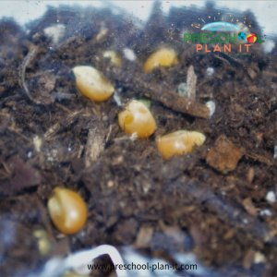
Growing Corn!
Materials: unpopped popcorn, Ziploc baggies, soil, water
The children place dirt in a Ziploc baggie.
Add water to make the dirt moist (but not soaked!)
Add a few kernels of popcorn.
Seal baggie. Have children mix.
Tape to a sunny window. There should be signs of growth within a week.
Investigation Station
Materials: Provide magnifying glasses, Indian corn, corn on the cob, feathers, pumpkins, etc. on a table for science exploration.

