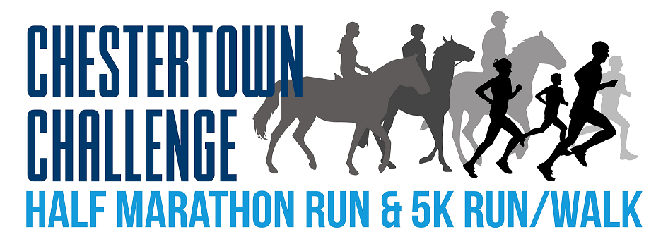

Sunday, October 12, 2025

Wilmer Park, Chestertown, MD
9:00 a.m.

Register online at
https://runsignup.com/chestertownchallenge

Or Race Day at 8:00 a.m.
Both courses USATF Certified

BENEFITS
KENT ASSOCIATION OF RIDING THERAPY (KART)


