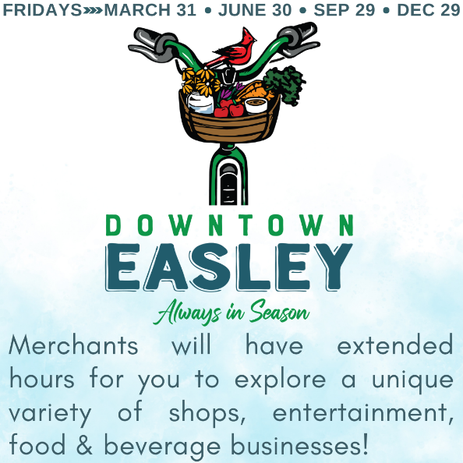
Downtown Easley – Always in Season – Summer 6/30 Event Details
As a valued Downtown Easley Business Council (DEBC) member, you are invited to join our Downtown Easley - Always in Season events. It's four Friday nights in the year where we encourage you to extend your business hours so that visitors can explore your unique business in Downtown Easley. In addition, you can offer a discount or a special to get more foot traffic to your doors.
By choosing to participate, you will be advertised on the chamber's "Always in Season" landing page and on social media. Through social media, your business will have its own graphic with your hours and selected special/discount/offer. This graphic will be available for your use.
For the Summer 6/30 event, we are offering an additional option: a giveaway that will be raffled off through social media posts on Facebook and Instagram. This is to increase traction for seasonal events and more traffic to your social media pages. For an individual to have a chance at winning your giveaway, they would need to do three requirements:
- Follow your business page and the Downtown Easley Business Council Page
- Like the post
- Tag someone in the comment section
If you are interested in doing a giveaway post, please create a giveaway of your choice (can be an item, a gift card, or a basket from your business). After that, the content will be created and shared with you along with details on when it will be scheduled. From there, your only task is selecting the winner because all your social media content will be created for you for these events. You will also be tagged to the giveaway announcement posts and the posts themselves.
To get started, please fill out the content below
Your Business: _______________________________________________________________________
Extended Hours: _____________________________________________________________________
Special Offer or Discount: ______________________________________________________________ ___________________________________________________________________________________
Giveaway: __________________________________________________________________________
Where do you want your business linked to: Website Facebook Instagram ________________

To participate in the June 30 event, please return this form to the chamber office or email it to Neydi Ramirez at nramirez@easleychamber.org no later than 5:00 PM on Wednesday, May 31. To get ideas, view the participants from the 3/31 event by scanning the QR Code. We look forward to seeing your participation. For questions, call (864) 859-2693, email Neydi or contact a DEBC representative.

