Belfast Rotary Club 2021 Belfast Harbor Fest
PRESS RELEASE

For immediate release
September 20, 2021

Contact:
Mickey Sirota, 2021 Belfast Harbor Fest Sponsorship Co-Coordinator
207 322-5671
mickeysirota@gmail.com

Rotary Club’s Harbor Fest “A Real Success”

The 14th annual Belfast Harbor Fest, presented to the community by Belfast Rotary Club in August, provided boatbuilding, music, food, crafts, children’s activities and more to nearly 2,000 people over two days.

“With the support of more than three dozen sponsors and the participation of more than 100 boatbuilders, runners, entertainers, exhibitors, vendors and Rotary volunteers, the event was a real success,” said Rotary Club president John Golden. “In spite of the challenges of COVID-19 and a wild Saturday afternoon thunderstorm, Rotary raised more than $28,000, provided nearly $3,000 for the Waldo County Pet Food Pantry, and the proceeds will be used for community service projects ranging from support for food pantries to help for needy families to holiday gifts for more than 150 children.”

Among Harbor Fest’s highlights were the National Boatbuilding Challenge, Front Street Shipyard tours, a classic boat show, marine equipment swap, entertainment by local musicians and the Frogtown Mountain Puppeteers, the 5K Bug Run road race, a Touch-A-Truck activity and an online charitable auction. Sunday morning featured a just-for-fun Cardboard Boat Race with seven entries, two of which sank safely but spectacularly.

“We couldn’t have gotten this done without all those volunteers and the support of the City of Belfast and its Parks and Recreation folks,” Golden said. “We are especially grateful to major sponsors First National Bank and First National Wealth Management, the Maine Bicentennial Commission, Front Street Shipyard, Nordic Aquafarms, Down East Credit Union, Waldo County General Hospital, and United Farmers Market. Thirty-seven generous local businesses and two dozen vendors, exhibitors and individuals made this all possible. It takes more than thunder and lightning to keep a good Rotary Club down.”

The 2022 Belfast Harbor Fest is scheduled for August 19, 20 and 21, 2022 on the Belfast waterfront.
Belfast Rotary Club, founded in 1925, is one of the largest and most active clubs along the midcoast. Its motto is “Service Above Self.” The club’s nearly 75 members provide more than $120,000 in charitable gifts each year, including support for seven local food pantries and food kitchens, more than $80,000 in scholarships to area high school students and holiday gifts to more than 150 children from low-income families. Belfast Harbor Fest is one of its largest fundraising efforts, which also include a charitable golf tournament, pancake breakfasts and auctions. Belfast Rotary meets every Wednesday at noon on Zoom and, when safe to do so, at the Shrine Club on Northport Avenue in Belfast.

Photos Attached Courtesy of Belfast Rotary Club (Phil and Mary Carthage):
Cardboard Boat Race Bubbles!
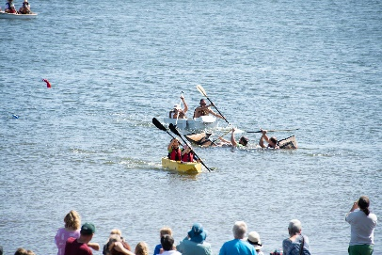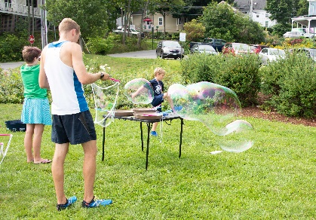
Boatbuilding Overview
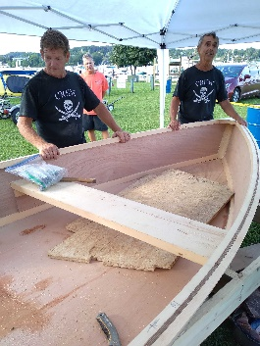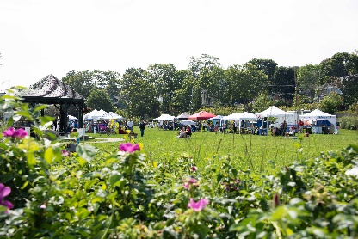
Storm Touch A Truck
