Fling Into Fall
Scarecrow & Pumpkin Carving Contests
Friday & Saturday October 8th & 9th
HOSTED BY Bangor Savings Bank
Located at the Penobscot Marine Museum

CATEGORIES
Businesses & Community groups - Children 12 & under – Adults
- All contestant entries must be registered with BSB by Friday October 8th (name, phone number and category)
- Scarecrows and pumpkins may be set up Friday night or before 10:00 am Saturday and marked with the artists name
- Winners will be notified
- 1st place winners - $25.00 BSB gift card
- Entries must be cleaned up by end of day Sunday, October 10th
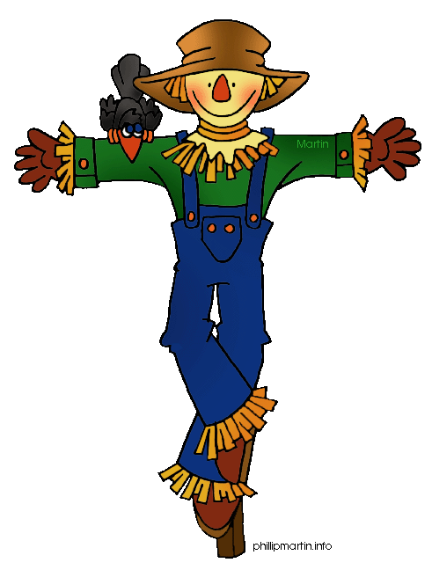

For more information contact:
Searsport Bangor Savings Bank (207) 548-6065
Caitlin.merithew@bangor.com

