FOR IMMEDIATE RELEASE
July 8, 2021

Photo Captions below text of press release.

Contact: Mickey Sirota 207 322-5671 mickeysirota@gmail.com

BELFAST ROTARY CLUB’S HARBOR FEST SET FOR AUGUST 13-15

Harbor Fest, Belfast Rotary Club’s free three-day celebration of the city’s maritime history and traditions on Friday, Aug. 13 through Sunday, Aug. 15, will provide a boatbuilding competition, entertainment, food, a rowing regatta, shipyard tours, a cardboard boat race and more at the Belfast waterfront.

“After a year off in response to public safety regulations, Belfast Harbor Fest is back with its Maine Bicentennial edition,” said long-time event chairperson Duke Marston. “This is the fourteenth celebration,” he added, “and we’ve learned a thing or three. Instead of a big tent, we’ll have smaller pavilions for each of the National Boatbuilding Challenge teams, and there may be a smaller children’s area. But people coming down to the waterfront are guaranteed a good time. There will be a Friday night auction to benefit the Waldo County Pet Food Pantry, our famous Saturday morning blueberry pancake breakfast, the popular 5K “Bug Run,” music, food trucks, the Come Boating! regatta and tours of Front Street Shipyard. And Sunday morning the Cardboard Boat Race, complete with “Best Sinking” prize, will cap off a weekend of fun.”

The art chosen as the graphic theme for this year’s Harbor Fest is “Last Light of Day,” an original work by Belfast artist and gallery owner Joanne Parent. Parent has generously donated the work, with a value of $2,800, to the “Evening by the Bay Online Auction” which will be held August 13 to 15. The internet-hosted auction, which kicks off the weekend waterfront celebration, will benefit the Waldo County Pet Food Pantry.

Marston thanked the dozens of sponsors, exhibitors, vendors and boatbuilding participants, with special mention of major sponsors First National Bank, First National Wealth Management, Front Street Shipyard, City of Belfast, Nordic Aquafarms and the Maine Bicentennial Commission. “An event this large takes a village, and Belfast area people have really come through after a rough year,” he said.

Belfast Rotary Club, founded in 1925, is one of Maine’s largest and most active clubs. Its members meet in person or by Zoom Wednesdays at noon at the Shrine Club in Belfast. The Club raises funds year-round through activities such as the Belfast Harbor Fest, annual charitable golf tournament event, 5K road races and pancake breakfasts. Its nearly $135,000 in yearly gifts include support for seven food pantries, year-end holiday clothing and toys to 150 children and $80,000 in scholarships for local college-bound high school students. For more information on membership or to make a tax-deductible donation in support of the Club’s year-round service programs, go to belfastrotary.org.

PHOTOS AND CAPTIONS - on next page
(photos attached as .jpg files – cuts below for illustration only):

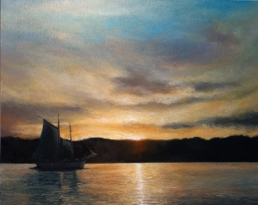

“Last Light of Day,” Belfast artist and gallery owner Joanne Parent’s tribute to Belfast Harbor and the Belfast Rotary Club’s 2021 Bicentennial Harbor Fest graphic theme.
PHOTO COURTESY OF JOANNE PARENT

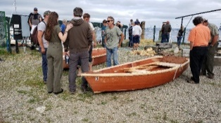
Completed skiffs prepare to race as part of Belfast Harbor Fest’s 2019 National Boatbuilding Challenge.
PHOTO COURTESY MICKEY SIROTA, BELFAST ROTARY CLUB

A team works on its 12’ skiff during Belfast Harbor Fest’s 2019 National Boatbuilding Challenge.
PHOTO COURTESY MICKEY SIROTA, BELFAST ROTARY CLUB

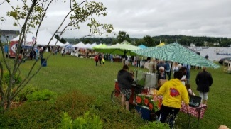
Belfast Harbor Fest at Steamboat Landing in August 2019.
PHOTO COURTESY MICKEY SIROTA, BELFAST ROTARY CLUB

