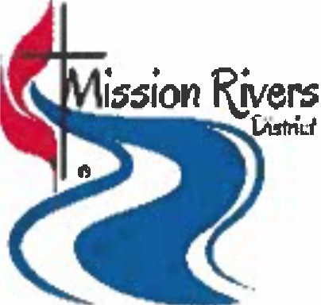
Vision:

Mission Rivers District Grants

The vision of the Mission Rivers District Committee on Missions is to encourage and assist churches, individuals, and groups to be in mission with their communities in making disciples of Jesus Christ for the transformation of the world.

Goals:

To make disciples of Jesus Christ
To strengthen, develop, and renew Christian congregations and communities To promote and support educational and missional concerns
To assist churches in need of repairing, maintaining, or upgrading their facilities To inform churches on mission opportunities and to encourage active participation from all district churches

The Mission Rivers District recognizes the importance of the measures of Vital Congregations. The Mission Committee shall disburse grants contingent upon the project's potential to satisfy one or more of the five areas of Vital Congregations listed below:

Vital Congregations:

Worship Mission Evangelism Stewardship Discipleship
Key Areas of Vitality:

Average weekly attendance
Professions of faith Small groups Members in mission
Dollars given to mission

Grant Request Process/Policy

- Churches are encouraged to meet their District Apportionments. These District Apportionments help make these and other grants possible.
Please state whether your church is current in paying its District Apportionments. If not, explain your extenuating circumstances. Churches are encouraged to partner with other District churches in mission opportunities supported by grants.
- Churches are limited to requesting a Grant to three years for the same mission. However, if the mission is on-going, the Committee may consider one-year extensions for additional years.
- One church may request more than one grant.

- Grant Requests Approvals:

The Church shall provide Church Council or equivalent body minutes with approved date.
A Non-church Organization shall provide minutes of its governing board with the approved date.
- The Committee on Missions and/or its Grants Group will meet throughout the year to discuss other possible/unforeseen grant request(s).
- The Grant Application will be made available by the first Friday of October each year.

- The Grant Application will be emailed to each church office, pastor, church lay leader and church council (or equivalent) chair in the Mission Rivers District, as well as previous recipients of the grant (if they are within the guidelines above). The application will also be available on the District website.
- Organizations wishing to submit an application:

must have the completed form with supporting documents into the District Office no later than the first Friday in December each year.
after submitting the application by email, or mail, must contact the District Office to be sure it was received.

- The Committee and/or Grants Group will review the requests and begin the interview process.
Each interview team will consist of at least two members from the Grants Group.
Any organization or group requesting a grant must be interviewed prior to a Committee recommendation to the District Board of Directors.

- The Committee and/or Grants Group will meet to discuss the applicants and their interviews and to decide on the awarding of grants.
- The final authority to award grants resides with the District Board of Directors, which typically will meet to consider grants in February. First checks to recipients usually will be sent in March.
If the grant is for a mission trip, the money will be dispersed when the group requests the money.
If the grant is for an annual outreach program, the money will be dispersed on a quarterly basis.
  - Annual programs need to provide quarterly reports to the Grants Group outlining what they have accomplished with the monies.
  - The quarterly report needs to be received and reviewed by the Grants Group before the next quarterly check is sent.
If the grant involves a major purchase, payment will be made from the District directly to the vendor.
- The Grants Group will review the Grant Application (form) and make changes as necessary.
- The Committee shall recommend to the District Board of Directors the amounts to disperse and inform applicants of their recommendations. The Directors ultimately have the authority to approve/disapprove the recommended amounts.
- All recipients are expected to submit a progress report or a complete report within 30 days of the scheduled completion date of each year's work on their mission/project. Future funding is contingent upon evidence of effectiveness of the programs.
- Grant Recipients shall return all unused funds for the grant project within 30 days of the scheduled completion date.

