South Texas with a Twist

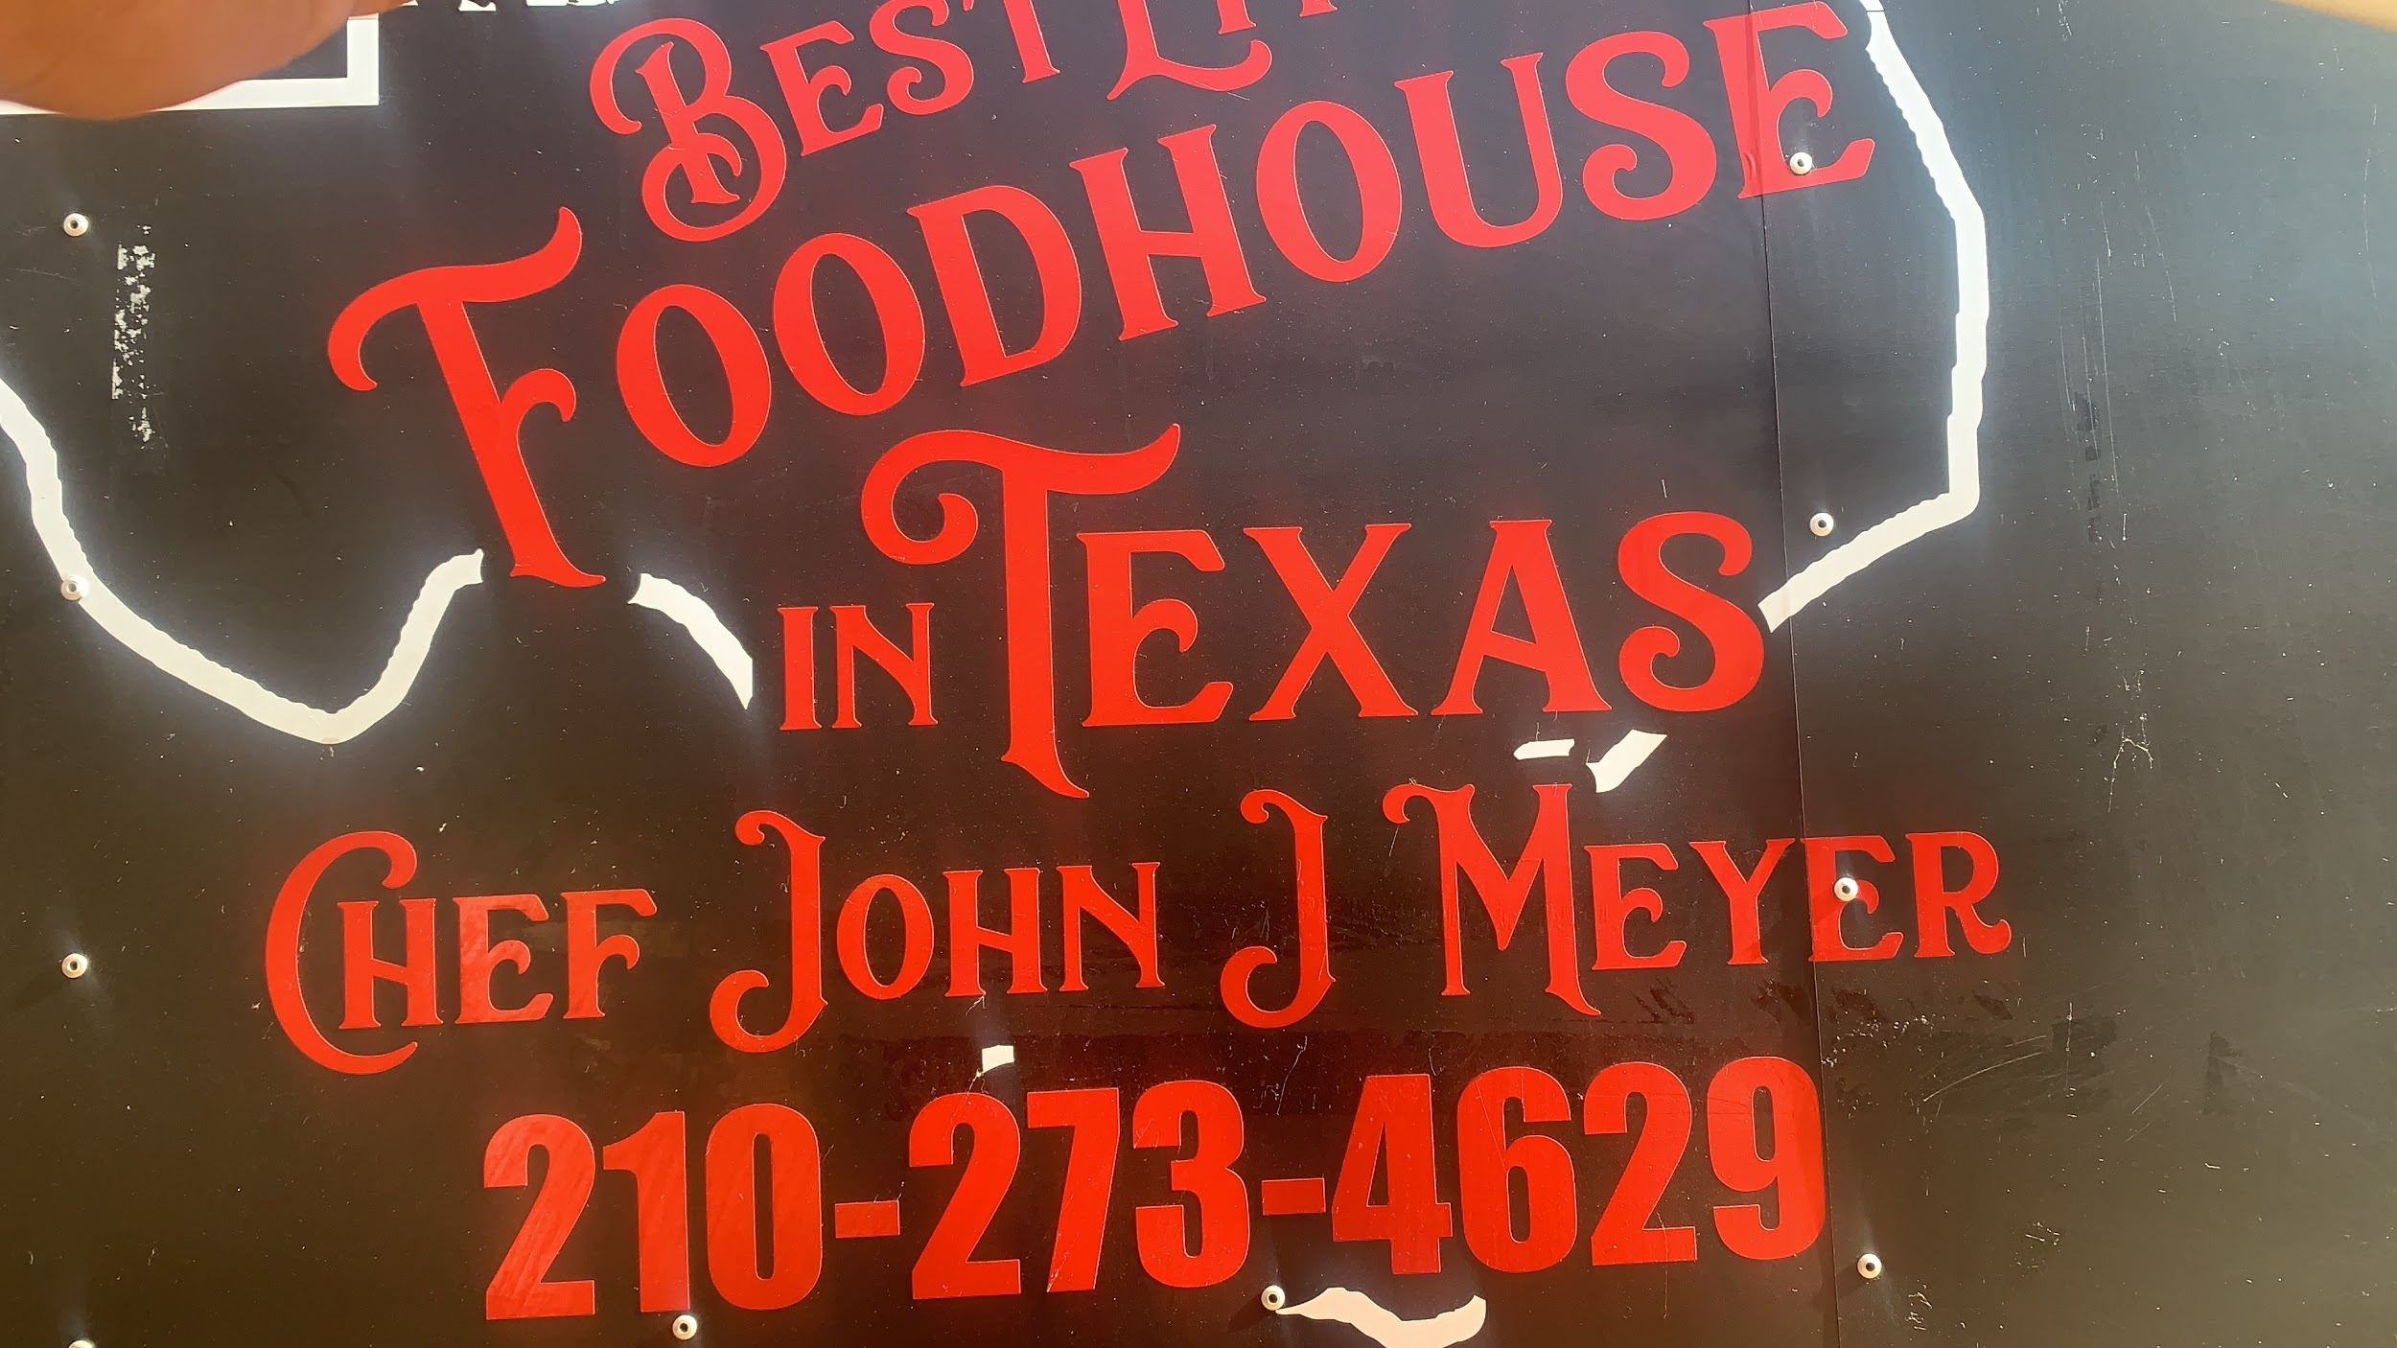

SA STREET TACO * $12.00

Asada, El Pastor, Smoked Pork Belly, Shrimp, Fish,

24hrs Smoked Brisket or Smoked Chicken

*Mini Corn Tortillas *Mini Flour Tortillas *Fresh Lettuce

All Tacos come w/Cheese, Fresh daily Pico De Gallo, Homemade Salsa & Thai Slaw

Osso Bucco Wings * $13.00

Your Choice of

Texas Style Cilantro Buffalo * Garlic Lemon Pepper * Thai BBQ Style

(4) Mini Texas Size Sliders * $14.00

24hrs Smoked Texas Style Brisket

SW (Fresh Pico De Gallo, American Cheese)

Smoked Bacon Cheese

Ranch or Blue Cheese Smoked Bacon

Grilled Chicken Breast w/Smoked Bacon, Provolone Cheese & Ranch

All sliders made with 100% Ground Ribeye w/Fries

SA Wrap * $15.00
Ribeye Hamburger Patty, 24hrs Smoked Brisket BBQ Sauce Wrap in a Jalapeño/Cheddar Cheese 12” Flour Tortilla,
4 slices of Cheese, Sliced Avocado topped /
Pico de Gallo on a bed of Fries!!

There is no other than the original “OG” created for
San Antonio from a hometown boy!!!

by Chef John J Meyer

Bentos Meets South Texas!

