Our core word for the next two weeks is: GIVE

Ideas to utilize “GIVE” at home:
- During snack, you can model “GIVE” or “GIVE me” when passing out plates, cups, napkins, etc.
- If your child enjoys hugs, squeezes, tickles, etc. you can model “GIVE” or “GIVE me tickles/squeezes/hugs” to request and exchange of affection.
- While playing with toys your child enjoys, you can model “GIVE” or “GIVE me” to request for the desired item.
Ways to model in addition to saying the word:
Sign:  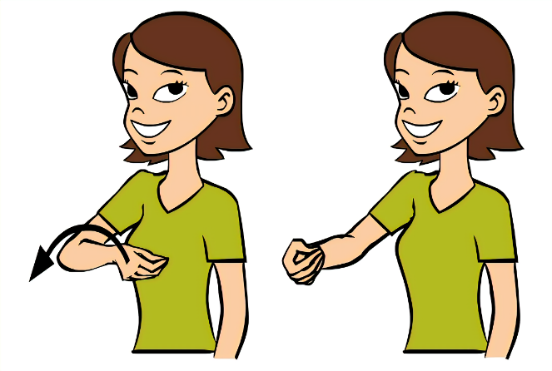 | Speak For Yourself AAC app:  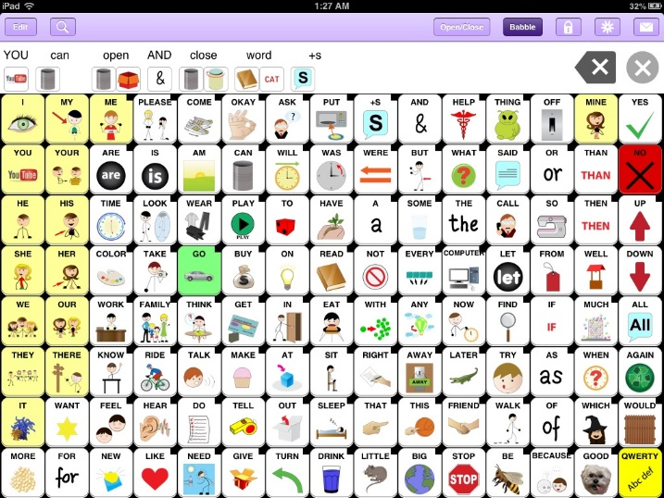
Picture: *print this out for your child to point to or give to you to participate in your communication interaction*  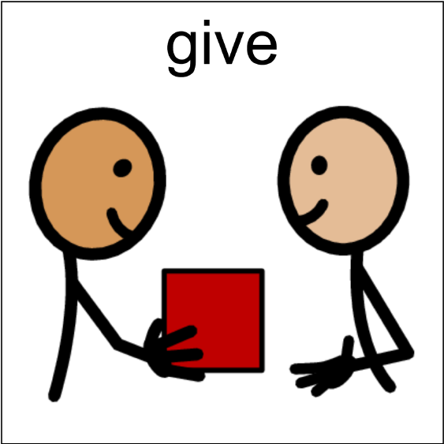 | Words For Life AAC app:  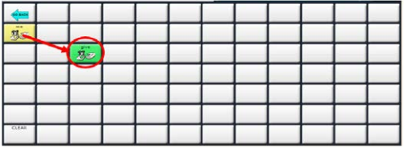  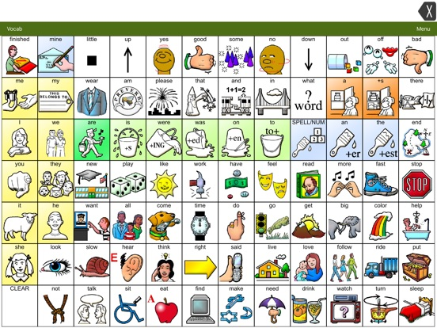
Disclaimer: These are the most frequent forms of communication The Emerge Center uses; however, please let your therapist know if your child uses a different form or communication. They will work with you to ensure you know exactly where to find these core words.

