AMERICA MAGAZINE, June 11, 2025

FaithFaith and Reason

Archbishop Weisenburger: Immigrants are—and always have been—the lifeblood of America.
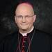
Edward J. WeisenburgerJune 11, 2025
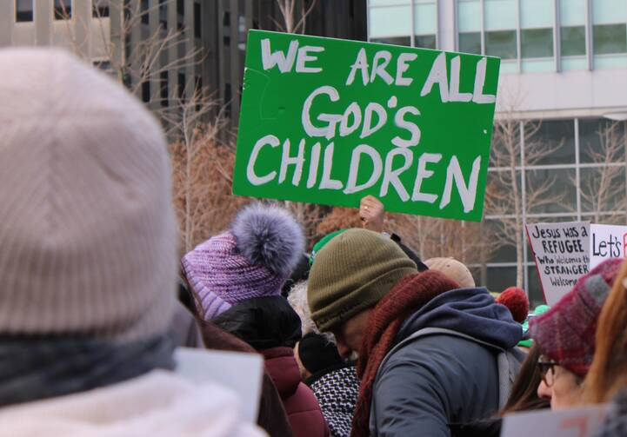A participant holds a sign during a Jan. 25, 2025, interfaith rally in support of immigrants at Love Park in downtown Philadelphia. A federal judge on April 11 declined to block the Trump administration from carrying out Immigration and Customs Enforcement actions at what are seen as sensitive locations, including houses of worship. (OSV News photo/Gina Christian)
Even before our nation’s founding, immigrants came to this land seeking freedom from persecution, greater economic opportunity and the ability to raise their families in peace. In addition to their hopes and dreams, they brought with them a spirited determination, unbridled ingenuity and, in many cases, an unshakeable faith in God.
Fundamentally, little has changed between those first immigrants and the German, Irish and Chinese immigrants of the late 1800s, the Italians and Poles of the early 1900s, the displaced Europeans seeking to start anew in the aftermath of World War II, the Cubans and Eastern Europeans fleeing communism during the Cold War, and the most recent immigrants from Latin America, Africa and Asia. With each wave, a new life and renewed vitality have been breathed into their receiving communities.
And just like those who once entered through Ellis Island by the boatful, people still set out for the United States with an earnest desire to meet the needs of their families and to contribute to the same cultural fabric that has made this experimental country so great.

A broken system
While these various waves of immigrants have much in common, however, the U.S. immigration system has largely failed to keep pace with the needs of American communities and the realities of the 21st century.
With all the talk about the need for people to immigrate “the right way,” one cannot help but ponder: “What is the right way?”
Limits on legal immigration, whether family- or employment-based or for the purposes of seeking humanitarian protection, have significantly increased since the 1920s. According to the Cato Institute, only about 3 percent of the people who submitted green card applications were slated to receive them in 2024.
For some visa applicants from certain countries, the wait time easily exceeds 100 years. Meanwhile, the children of temporary immigrants, many of whom have grown up in this country and know it as their only home, face losing their legal status once they reach the age of 21, giving them little choice but to depart the United States for unfamiliar shores, thereby depriving us all of their homegrown potential.
Even the Catholic Church and our fellow employers of foreign-born religious workers are grappling with the constraints of an immigration system that is ill-equipped to meet the demands of our diverse flocks, forcing us to lose men and women who have faithfully served communities in the United States for several years.
This is to say nothing of the asylum system, which puts people who have fled life-threatening situations into a years-long backlog, expecting them to consistently and accurately recount several times over that same timeframe the horrors they experienced before reaching this country, frequently without the benefit of any legal counsel. And that is assuming they are afforded an opportunity to present their case at all, which is unfortunately not happening for many in light of current policies.
Meanwhile, Congress has repeatedly failed to enact meaningful immigration reform over recent decades, leaving family members separated, employers without workers and people seeking humanitarian protection unable to receive a fair and timely decision in their case.

The face of the other
The 20th-century French philosopher Emmanuel Levinas coined a phrase that is also at the foundation of his ethics: “the face of the other.” For Levinas, who spent time as a prisoner of war in Nazi Germany, to look into the face of the other is to discover an inviolable demand of reverence and dignity for the one before us. He also concluded that to look into the face of the other is to experience a revelation that demands a humane and compassionate response. To fail to do so dehumanizes both the other and ourselves.
Perhaps it is not surprising that with wars fought at great physical distance, with hate speech typed anonymously into computers or with the collapse of in-person relationships that build authentic community, there is less reverence today for the inherent dignity of every human being. In the language of Levinas, we no longer look into the face of the other.
But having spent seven years as the Catholic bishop on Arizona’s border with Mexico, I have been privileged to look often into the face of the immigrant, including those seeking asylum. What I have encountered is indeed what Levinas would term a radical, unyielding demand for reverence and compassion. What I have experienced is also consistent with the Catholic faith, which teaches that every human person possesses infinite and transcendent dignity.
Much of the Catholic Church’s response to the waves of immigration in the last several years on the Arizona-Mexico border was handled by Catholic Community Services of Southern Arizona. We collaborated with local county leadership and a host of ecumenical groups in managing federal funds provided to the county for this humanitarian response. We often received over 1,000 people per day, always brought to us by Border Patrol or Immigration and Customs Enforcement after being processed and provided legal documentation.
A host of volunteers was involved in each of these efforts, and I was both surprised and humbled by their commitment. I believe that once they found themselves looking into the face of one who had escaped the possibility of death, starvation or persecution, the intensity of the experience placed an ethical demand upon them. Having looked into the face of the other,they could not deny the humanity they saw or the response of dignity and compassion it demanded of them.
In the Catholic tradition, we judge ourselves as a community of faith by the way we treat the most vulnerable among us. The treatment of migrants poses a particular challenge to the consciences of policymakers, immigration enforcement officers, residents of border communities and providers of legal aid and social services, many of whom share our Catholic faith. But as a people largely comprised of immigrants, at one point in our family’s history or another, the current inadequacies of our immigration system—and the pain it inflicts on people and communities—should give each one of us reason to pause and reflect—and to demand something better. We cannot remain silent in the face of policies that result in human suffering, family separation or the cruel treatment of the undocumented immigrant.
After all, would many of us present-day descendants of immigrants be here right now if the U.S. immigration system treated our ancestors in the same way it treats people today?

Recognizing our shared humanity
Few, if anyone, are questioning the need for a just enforcement of immigration law or the importance of promoting public safety. Catholic teaching recognizes each country’s right to regulate its borders in accordance with the common good, to protect its existing residents and to bring to justice those who commit crimes.
But, as our late Pope Francis reminded us before his passing,
[A]n authentic rule of law is verified precisely in the dignified treatment that all people deserve, especially the poorest and most marginalized. The true common good is promoted when society and government, with creativity and strict respect for the rights of all…welcomes, protects, promotes and integrates the most fragile, unprotected and vulnerable. This does not impede the development of a policy that regulates orderly and legal migration. However, this development cannot come about through the privilege of some and the sacrifice of others. What is built on the basis of force, and not on the truth about the equal dignity of every human being, begins badly and will end badly.
The acknowledgment that our immigration system is broken is by now a time-worn statement. While I presume the good intentions of those who wish to address the issue, I would propose that a legitimate immigration system does not begin with mass deportations that lack any consideration of individual circumstances, including family ties. It cannot be founded on the dismantling of programs that have proven successful in aiding vulnerable people, with the foreseeable result being the starvation, extreme poverty or death of those with no voice. Moreover, while the lawful arrest of those engaged in criminal activity is appropriate, the criminalization of people based solely on their undocumented status undermines our moral obligations and falls tragically short of the noble history of our nation.
Any legitimate starting point for a new approach to immigration policy must begin by recognizing the humanity of the immigrant. A just, effective and authentically American immigration system will entail an orderly and fair pathway to legal status for those who have long contributed to our communities. It will ensure the protection and unity of families. Finally, it will balance a true respect for the sovereignty of nations with the moral obligation to care for the stranger in our midst.
In these ways, we will have looked into the face of the other and discovered that we have responded well.
Recent responses to those seeking relief at our borders and to the presence of undocumented immigrants residing within them—in some cases, for decades—fail to live up to the words famously inscribed on the Statue of Liberty, which has stood tall in New York Harbor as previous waves of immigrants sailed past: “Give me your tired, your poor, your huddled masses yearning to breathe free.”
Who are we as a country if we are unable to recognize and respond adequately to the same aspirations demonstrated by today’s immigrants that once defined the immigrants of generations gone by? One can hardly imagine.
More: Immigration / History / Catholic Social Teaching / Bishops
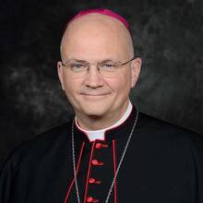
Edward J. Weisenburger
The Most Rev. Edward J. Weisenburger is the archbishop of Detroit.

