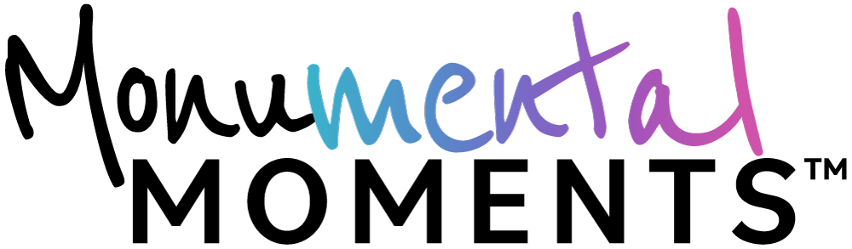Campaign Toolkit/Resources
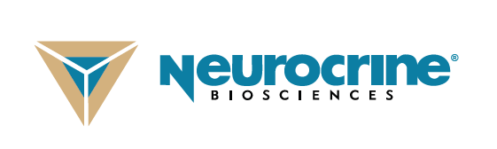
Foreword

We are living in an unprecedented time, when everyone’s mental health is being put to the test. This October 2020, during Mental Illness Awareness Week (October 4-10) and just before World Mental Health Day (October 10th), Neurocrine Biosciences in partnership with the Me2/Orchestra and the mental health advocacy community is creating Monumental Moments™, a community platform to celebrate all the ways people are caring for their mental health during this difficult time.

The goal of Monumental Moments™ is to foster the spirit of togetherness and support for people in the mental health community - along with those in the general public - who have experienced a heightened sense of anxiety and stress during this very challenging year of social distancing and unrest. The program’s microsite, MonumentalMoments.com, will serve as the platform where people can learn more about the initiative, how they can participate, and be connected to a variety of mental health resources.

To participate in the community platform, it’s simple:
- Post an image, video, or status update to your preferred social media channel that shows a moment that was meaningful in caring for your mental health.
- Use the hashtag #MonumentalMoments and tag three friends to grow the community.

Public posts shared on social media using the hashtag #MonumentalMoments will help support people living with mental health conditions, including those also living with an involuntary movement disorder called tardive dyskinesia (TD). On behalf of posts shared, Neurocrine will be making donations to mental health organizations as part of its commitment to support people living with mental illness.

Thank you for your participation and efforts around raising awareness for mental health and its related conditions as we face these monumental times together! Enclosed please find template materials which can be adapted for media outreach and communication around the Monumental Moments™ community platform.
If you have any questions, please reach out to Michele Rest, Corporate Communications, Neurocrine Biosciences, Inc. (215-910-2138; mrest@neurocrine.com), Todd Bledsoe, Patient Engagement and Advocacy, Neurocrine Biosciences, Inc. (202-236-8202; tbledsoe@neurocrine.com) and Chuck Harman, Patient Engagement & Advocacy, Neurocrine Biosciences Inc. (858-245-5871, charman@neurocrine.com).

Monumental Moments™
Campaign Toolkit/Resources Table of Contents

- Template Emails/Websites………………………….…………………………………………….…………………………………..4-5

- Template Social Media Posts…………………………………………………………………….……………………………………...6

- Backgrounders…….…………………………………………………………………………………………………………………………7-8

- Ad Template……………………………………………………………………………………………………………………………….…….9

- Zoom Backgrounds………………………………………………………………………………………………………….……………….10

- Logo Sheet……………………………………………………………………………………………………………………………………..…11

TEMPLATE EMAIL/WEBSITE POST
Enclosed are two templated news briefs, which each advocacy organization can tailor to share as an email to respective internal and external distribution lists as well as for posting on respective websites. Placeholders are included throughout to tailor content accordingly. We recommend sharing the first email/post on Wednesday, October 7th, in the morning to kick off Monumental Moments™.

We recommend sharing the second email/post on Wednesday, October 28th, in the morning to announce the virtual performance of Me2/Orchestra which can be found on MonumentalMoments.com/Me2Orchestra.

EMAIL POST #1 – To be used at the reveal of Monumental Moments™ on October 7th

[IF SENDING AS AN EMAIL, INSERT:
Dear All,]

It’s okay not to be okay, especially during a global health crisis. Many experts advise that sharing how you feel can help process emotions – for you and for others. We are living in an unprecedented time, where everyone’s mental health is being put to the test. This October, right before World Mental Health Day (October 10th) and during Mental Illness Awareness Week (October 4-10th), the Me2/Orchestra, the world’s only known classical music organization created for individuals with mental illness and the people who support them, and Neurocrine Biosciences in partnership with the mental health community will reveal the charitable initiative and community platform, Monumental Moments™.

For those who feel alone in these times of social isolation, building connections is more important than ever. Join the Monumental Moments™ community and celebrate your stories – together. Your Monumental Moment will help others in the community. Your public post on social media using the hashtag #MonumentalMoments will help support people living with mental health conditions, including those also living with an involuntary movement disorder called tardive dyskinesia (TD). On behalf of posts shared, Neurocrine Biosciences will be making donations to mental health organizations as part of its commitment to support people living with mental illness.

- Celebrate your Moment – Post an image, video or status update of your moment to your preferred social media channel (like Facebook, Twitter or Instagram).
- Use the Hashtag – Use the hashtag #MonumentalMoments to connect and share your moment with others. Your post may also appear on this website in our gallery of moments.
- Share to Care – Tag three friends (or more!). By sharing, you’ll help build the community.

Thank you for joining the Monumental Moments™ community and celebrating all the ways you are caring for your mental health during this difficult time.

[IF SENDING AS AN EMAIL, INSERT SIGNATURE:
Sincerely, NAME, TITLE]

EMAIL POST #2 – To be used at reveal of Me2/Orchestra’s virtual performance on October 28th

[IF SENDING AS AN EMAIL, INSERT:
Dear All,]

We may be living in unprecedented times, but music remains a way to connect during times of crisis. Research has shown that music has the potential to help those with mental illness. Me2/Orchestra, the world’s only known classical music organization created for individuals with mental illness and the people who support them, today released an original musical score.

The live virtual performance of 100+ orchestra members is happening today on MonumentalMoments.com/Me2Orchestra as part of Monumental Moments™. The score is inspired by the personal experiences and stories of the orchestra’s musicians and how they have coped during the pandemic.

For those who feel alone in these times of social isolation, building connections is more important than ever. Join the Monumental Moments™ community and celebrate your stories – together. Your Monumental Moment will help others in the community. Your public post on social media using the hashtag #MonumentalMoments will help support people living with mental health conditions, including those also living with an involuntary movement disorder called tardive dyskinesia (TD). On behalf of posts shared, Neurocrine Biosciences will be making donations to mental health organizations as part of its commitment to support people living with mental illness.

How to Participate:
- Celebrate your Moment – Post an image, video or status update of your moment to your preferred social media channel (like Facebook, Twitter or Instagram).
- Use the Hashtag – Use the hashtag #MonumentalMoments to connect and share your moment with others. Your post may also appear on this website in our gallery of moments.
Share to Care – Tag three friends (or more!). By sharing, you’ll help build the community.

Thank you for joining the Monumental Moments™ community and celebrating all the ways you are caring for your mental health during this difficult time.

[IF SENDING AS AN EMAIL, INSERT SIGNATURE:
Sincerely,
NAME
TITLE]

TEMPLATE SOCIAL MEDIA POSTS

Below are suggested template posts for your preferred social channel which can be tailored as appropriate. Post copy examples can be used interchangeably with the images available for download here (we recommend only using the donation graphic along with donation language). The most important component to include is the platform hashtag, #MonumentalMoments, as we are conducting social listening to identify mentions of the platform. Neurocrine Biosciences will also be posting from the @TalkAboutTD Twitter handle, which we welcome you to follow and engage with – we’ll be tagging all posts with #MonumentalMoments.

- We know times of uncertainty can cause feelings of anxiety, worry and helplessness. Use #MonumentalMoments to share how you are caring for your mental health during this time.
- We may not be physically together, but there are plenty of ways to stay connected while we are apart. How are you staying close to loved ones during this time? Share using #MonumentalMoments and visit MonumentalMoments.com to see others’ posts.
- On behalf of #MonumentalMoments posts shared, Neurocrine Biosciences is making donations to mental health organizations as part of its commitment to support people living with mental illness, including those also living with tardive dyskinesia (TD). Share your moment!
- Getting used to a “new normal” can affect mental health, but together we can support each other—even if we’re apart. Get inspired by how others are prioritizing mental health at MonumentalMoments.com #MonumentalMoments
- How are you taking care of your mental health during this time? Share it on your social platform of choice using the hashtag #MonumentalMoments to support people living with #mentalhealth conditions.
- Get inspired to prioritize your mental health and wellbeing by visiting MonumentalMoments.com. Posts using the hashtag are being shared to inspire the community—and you can share your moment, too by using #MonumentalMoments
- Big or small, all moments should be celebrated—there is no wrong way to tend to your well-being. What tips do you have for taking care of yourself during this time? Share using #MonumentalMoments
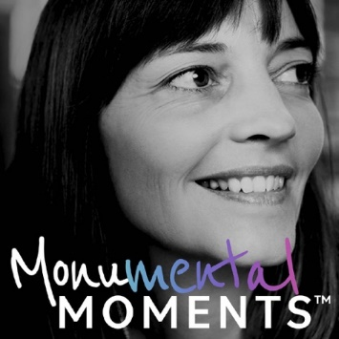

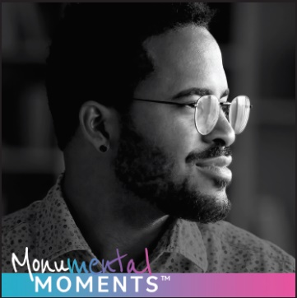
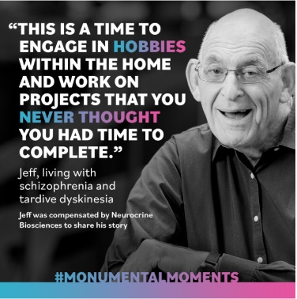
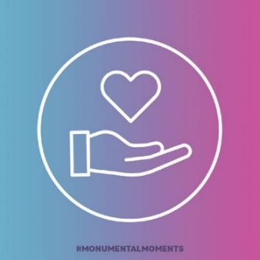
BACKGROUNDERS
TIME FRAME TO USE: October 7- October 28, 2020: This backgrounder should be used from October 7th-October 28th. Download here.

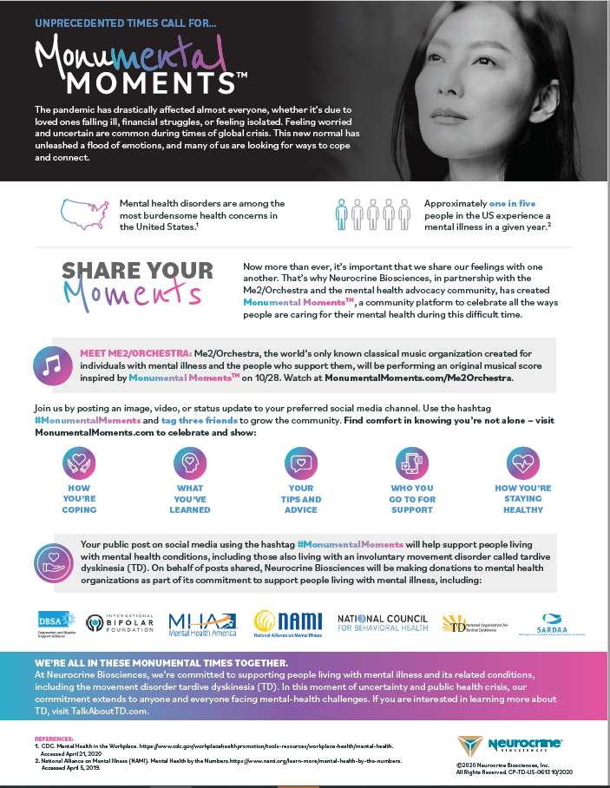

TIME FRAME TO USE: October 28, 2020-2021: This backgrounder should be used after Me2/Orchestra’s virtual performance on October 28. Download here.

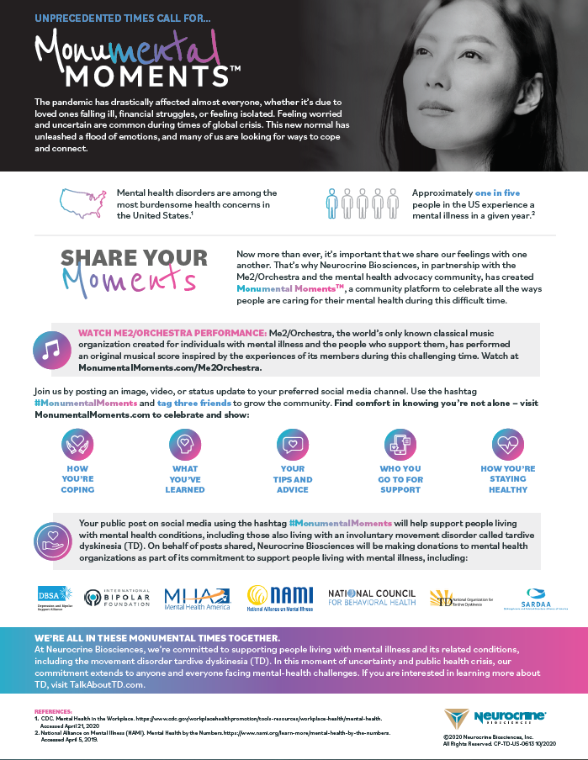

AD TEMPLATE
Ad template for Monumental Moments™. Download here. Different size templates can be requested, please email: SpectrumNeurocrine@spectrumscience.com.
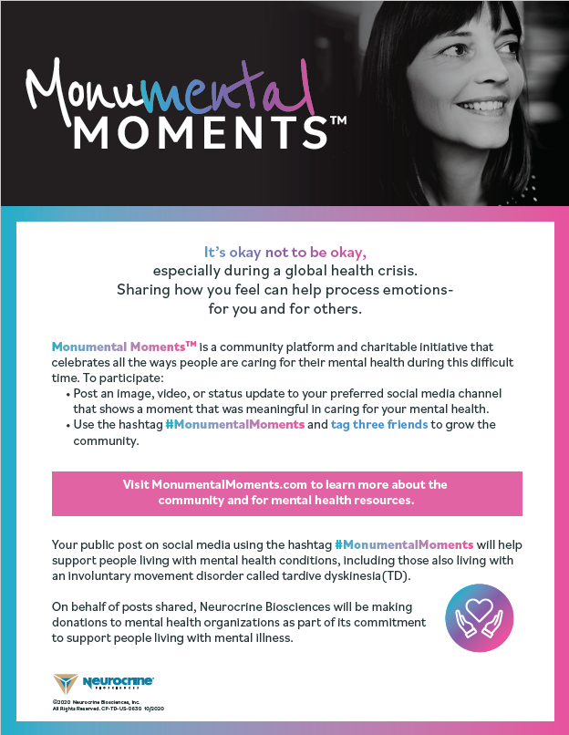

ZOOM BACKGROUNDS
Zoom backgrounds to show your support for the mental health community and Monumental Moments™. Download here.

LOGO SHEET
Download logos here.
Monumental Moments™ Logo Sheet
Description | Logo Style
Logo 1: Monumental Moments White + Gradient on Black Background

Monumental Moments logo in white with gradient on black background. Format shown is PNG but will also provide EPS and AI format in logo package.
Logo 2: Monumental Moments Black + Gradient on White Background

Monumental Moments logo in black with gradient on white background. Format shown is PNG, but EPS and AI versions will also be included in logo package.

Logo 3: Monumental Moments White + Gradient on White Background

Monumental Moments logo in white with gradient on white background. Grey background will not be shown in final logo format. Logo format is PNG but will also provide EPS and AI format in logo package.
Logo 4: Monumental Moments White on White Background

Monumental Moments logo in white on white background. Grey background will not be shown in logo format. Format shown is PNG, but EPS and AI versions will also be included in logo package.

