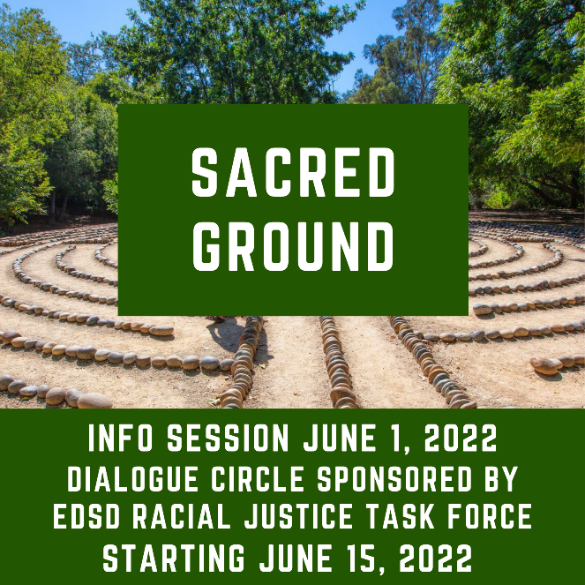

ANNOUNCING FIRST IN-PERSON SACRED GROUND CIRCLE!
Sacred Ground is a small-group film and reading based dialogue series on race, racism, and faith. This new live circle is sponsored by Incarnation Lutheran and St. Bartholomew’s Episcopal in Poway. Sessions will be held at Incarnation and facilitated by Colleen Chapin from St. Bart’s. Please make note of the following dates:
12 two-hour sessions will meet every other Tuesday 10:00 a.m. to Noon from February 7 to July 11. Attend an important information session on Tuesday January 24 from 10:00 to 11:00 a.m. at Incarnation.
Two additional Sacred Ground 12 session series are being offered by the Episcopal Diocese of SD via ZOOM:
Mondays 3:00 pm to 5:00 pm from February 13 to July 17 with a one-hour information session on Monday, January 23 at 3:00 pm.
Fridays 6:00 pm to 8:00 pm from February 17 to July 21 with a one-hour information session on Friday, January 27 at 6:00 pm.
Visit https://www.episcopalchurch.org/sacred-ground to learn more about this transformative program. Contact Jill Henderson at jfh@cox.net about other details and how to register.

