Synod Meeting Summary
May 2-3, 2021
The Synod of Lakes and Prairies held its Spring Annual and Stated Meeting on Sunday, May 2, and Monday May 3, 2021 via video conferencing program Zoom. This was the third time a Zoom meeting was held because of the global pandemic of COVID-19.

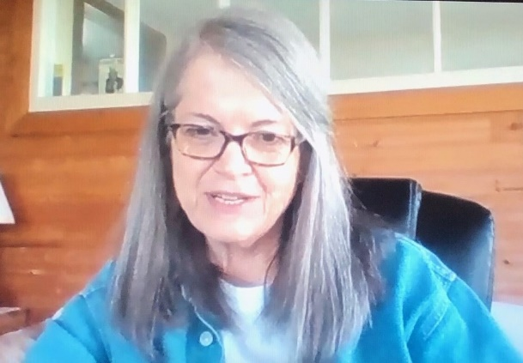  Moderator Janice Palmer | 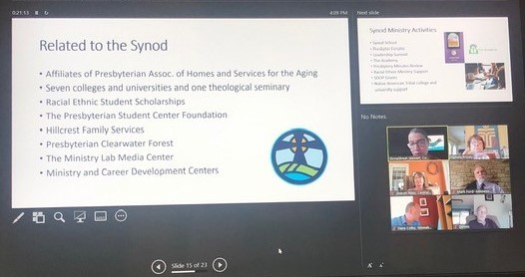  Synod Orientation
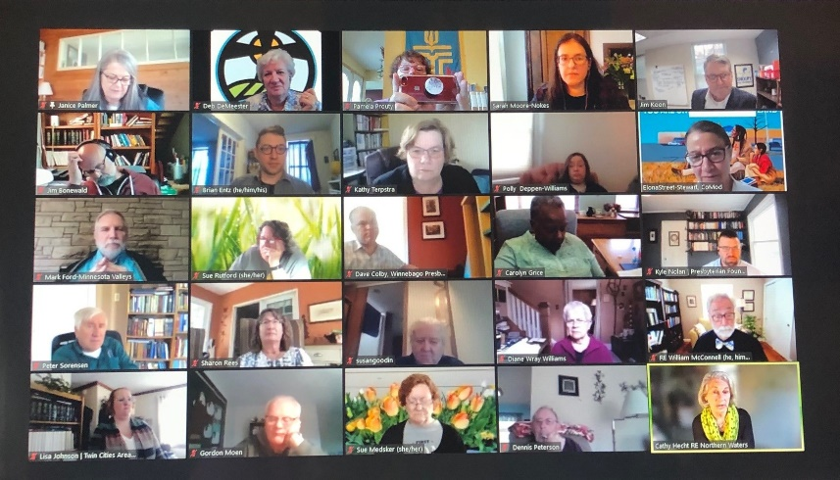
Moderator Teaching Elder Janice Palmer, commissioner from the Presbytery of South Dakota, called the Synod to order at 5:30 p.m. Prior to the call to order, an orientation was held for new commissioners and others hosted by Synod Executive Elona Street-Stewart and Stated Clerk Pamela Prouty. Synod Assembly
The Synod meeting started with worship where the Rev. Alonzo Johnson, Self-Development of People Coordinator for the General Assembly, preached a sermon on Matthew 25:31-46 entitled, “Have you Seen Me?” Communion was served, Janice Palmer, Synod Moderator, and Alonzo Johnson, Self-Development of People Coordinator, officiated.
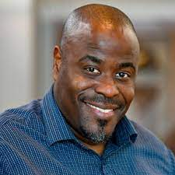
Following worship, Alonzo Johnson led an educational presentation on the history and mission of the Self Development committee. The Synod spent time in small groups.
Monday morning started with fellowship groups followed by reports from Synod staff and Synod committees. The Synod heard about many programs and events with which the Synod has been involved.
Rev. Alonzo Johnson,
Self-Development of People Coordinator

The Communications Committee introduced the new Synod Logo.
Synod Logo background
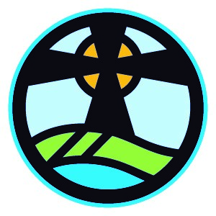
Our history, our present, and our future are represented in this logo.
The first presbytery west of the Mississippi River was the Dakota Presbytery, established in 1844 before territories became the states that now make up the Synod’s region. It was “bounded on the north by the International Line; on the west by the Pacific Ocean, on the south by Iowa and Missouri; and on the east by Wisconsin.” (Source: The History of the Dakota Presbytery of the Presbyterian Church in the United States of America, by Adams, Renville and Williamson, Good Will, SD, 1892)
Our Native roots are evident in the circle, reminiscent of the medicine wheel and our call to heal divisions, make amends, and further reconciliation through our ministries. The four quadrants remind us of the four directions (west, north, east, and south) which symbolize the life of both humans and the world in which we live.
The blue waters of the lakes and the green of the prairies remind us of the gifts that nurture us today and the gifts we will protect for tomorrow. Within the boundaries of our Synod, there are two of the Great Lakes, thousands of smaller lakes left behind by the last glacier, and numerous man-made lakes, all supporting wildlife, commerce, and recreational activities. The lines in the green speak to crops planted and harvested; we live in awe that food grown in this Synod is used around the world. The solid green reminds us of our prairie heritage and the ongoing effort to restore native prairies for future generations.
The center image prompts memory of our Scottish heritage as Presbyterians, represented by the Celtic cross. We also celebrate the gifts of creation, symbolized by the sun and its rays bringing growth and life to the world. The shape of the cross also suggests a wind turbine, thousands of which can be seen across the Synod, helping to lead us to a more sustainable energy future.
May the words of our mouths, the meditations of our hearts, and the work of our hands, bring the hope of God’s kin-dom to all.
Also, the Communications Committee introduced the new website at www.lakesandprairies.org. Go and check it out!

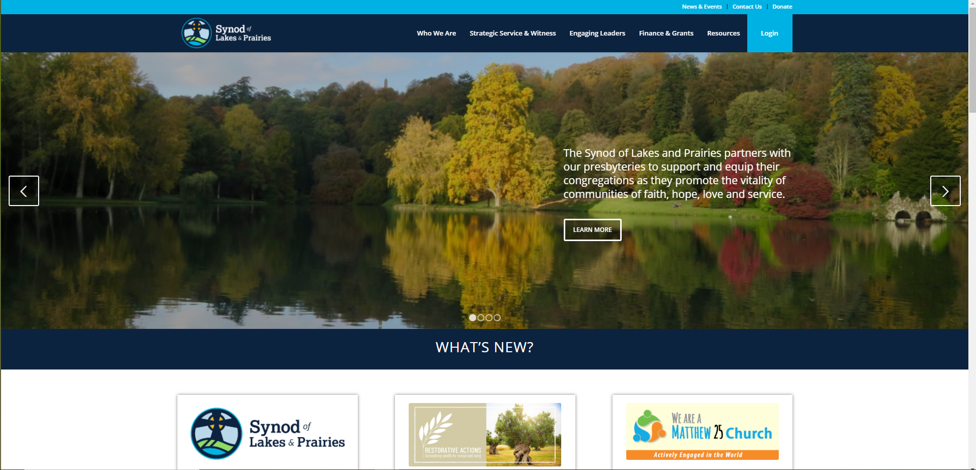
Synod website
The Synod re-affirmed their covenant agreement with Macalester College, something we do at least every 5 years.
On Monday afternoon, the Synod Restorative Action Work Team presented more information about how the Synod is moving forward in actions that are intended to be restorative to right relationships with the African American and Indigenous communities. Following the Synod action from Fall 2020 to set aside 15% of our reserves for restorative actions, the team has been developing two trusts through the Presbyterian Foundation and an additional $400,000 has been gathered in commitments for the program.
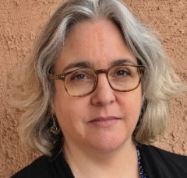  Rev. Molly Casteel, Manager, Equity and Representation Assistant Stated Clerk, PC(USA) | Jim Koon, Director of Financial Services,  Synod of Lakes and Prairies

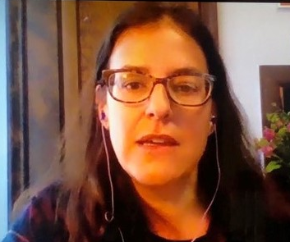
Rev. Sarah Moore-Nokes, Member at Large, Winnebago Presbytery, Wisconsin

In March of this year, Restorative Actions’ new website was introduced at the 2021 NextChurch Gathering.
In April, the New Covenant Trust Company made available a new investment fund that positively screens for companies with the strongest diversity, equity, and inclusion attributes among the Russell 3000 index.
The next meeting of the Synod of Lakes and Prairies will be October 3-5, 2021. Hopefully, we will be in person at the Mt. Olivet Retreat Center in Farmington, MN.

