The gifts Christ gave were that
some would be apostles, some prophets,
some evangelists, some pastors and teachers,
to equip the saints for the work of ministry
for building up the body of Christ,
until all of us come to the unity of the faith
and of the knowledge of the Son of God,
to maturity, to the measure of
the full stature of Christ.
Ephesians 4:11-13

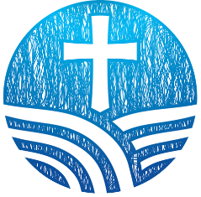

In Ephesians, we are reminded
that Christ calls and equips people within the church
to build up the body and strengthen its ministry.
I invite you to consider how God may be calling you
to grow in your own gifts for service.

Whether you are discerning a call to become
a Commissioned Ruling Elder or simply seeking
to deepen your ability to lead, care, or proclaim the Word,
these opportunities are offered to equip you for faithful ministry. I encourage you to take a step, explore these courses,
and join in the shared work of building up the church in love.

Together in Christ,
Rev. Beth Buckwalter-Miller, Executive Presbyter

We invite you to explore
where God may be leading you!

Who Is This For?
Ruling elders discerning a deeper call
Members interested in preaching or teaching
Those drawn to pastoral care ministries
Anyone wanting to grow in faith and leadership

Through these courses, you will:
Grow in biblical and theological understanding
Develop skills in preaching and care
Gain confidence in leadership
Serve your congregation more effectively

Discernment Questions
Where do you sense God calling you to serve?
What gifts for ministry are emerging in your life?
How might further training equip you to lead?

What is a Commissioned Ruling Elder?
A Commissioned Ruling Elder is a trained and authorized
ruling elder who serves in pastoral leadership —
often in congregations without installed pastors —
preaching, moderating session, and providing spiritual care
under the guidance of the presbytery.

How to Get Started
Pray and reflect on your call to serve.
Talk with your pastor or session.
Contact the presbytery office.
Register for a course.

Equipping the Saints
Pathways for
Ministry & Leadership

Courses for those discerning a call
to serve, grow in ministry skills, or
prepare as Commissioned Ruling Elders.

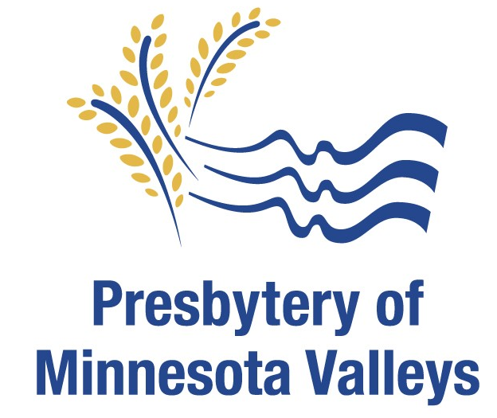

www.minnesotavalleys.org
320-235-7910

June 2026
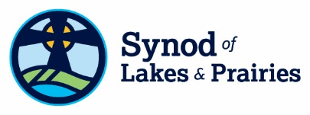
The Academy is a series of 12 courses offered by the Synod of Lakes & Prairies, which will prepare thoughtful, caring people to serve the church as Commissioned Ruling Elders (CREs).
The Academy courses are:
Congregational Revitalization Leadership & Administration
Pastoral Care Presbyterian Polity
Spiritual Formation Worship & Sacraments
Leadership 101 Mission Formation
Old Testament New Testament
Reformed Theology Preaching
www.lakesandprairies.org/the-academy


The Synod School of the Synod of Lakes and Prairies offers two of The Academy courses at Buena Vista University in Storm Lake, IA. The courses run for one week in July. www.lakesandprairies.org/synod-school

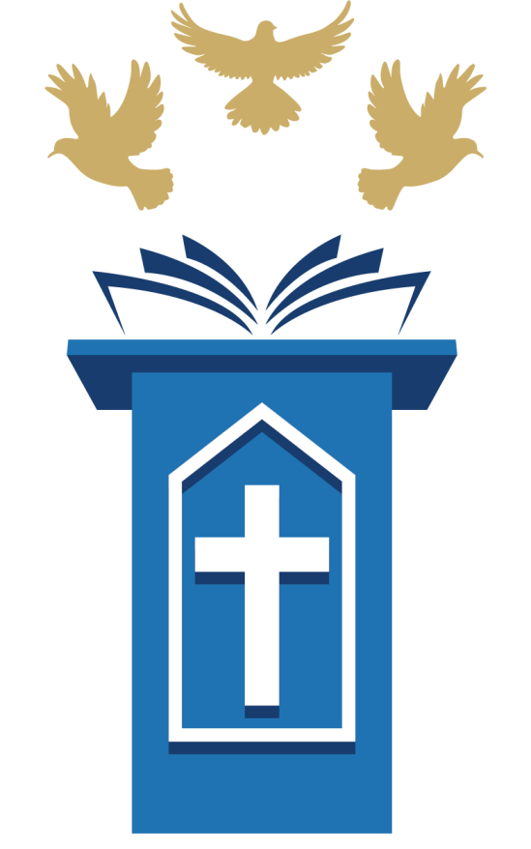
Omaha Presbyterian Seminary Foundation (OPSF) offers a Certificate in Proclamation consisting of four, six- week courses in Old Testament, New Testament, Reformed Theology, and Preaching. These courses may be credited to The Academy program.
www.omahapresbyterianseminaryfoundation.org/get-support/certificate-in-proclamation

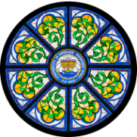
The University of Dubuque Theological Seminary (UDTS) offers two programs: a Certificate in Congregation Leadership (comparable to The Academy) and a Master of Arts in Ministry. UDTS courses may be applied to The Academy program.
www.dbq.edu/UDTS/AcademicPrograms/CongregationalEquipping/

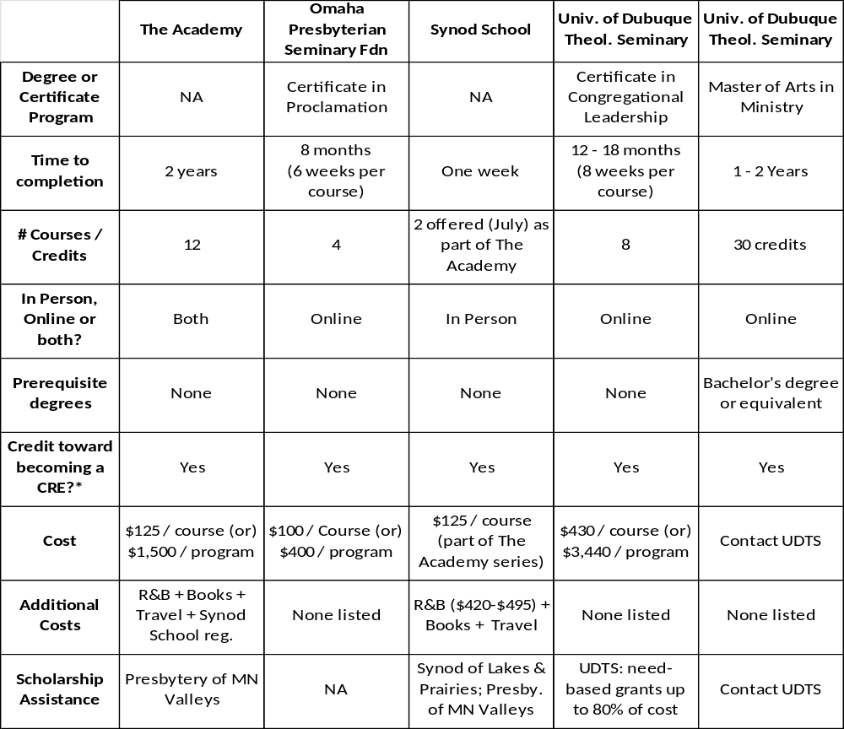

*Commissioning as a Ruling Elder is conferred by the student’s denominational judicatory (i.e., Presbytery).

