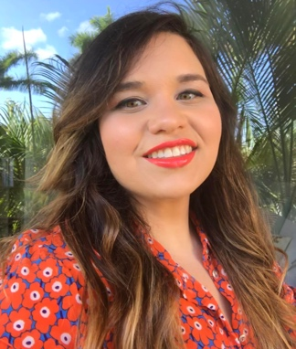
Cassandra Arissa Montenegro, Esq.
402 S Spring Street
Falls Church, VA 22046
(305) 801-3968 (cellular)
cmontenegro@hds.harvard.edu
(she/ella/her/hers)

Cassie Montenegro is a Master of Divinity student at Harvard Divinity School where she is the Graduate Research Assistant on the Unitarian Universalist History and Heritage Society Congregational History Project. She is a member of the Unitarian Universalist Congregation of Miami and is active in the First Parish in Cambridge People of Color Caucus. Last Fall, Cassie was awarded the Marjorie Bowens-Wheatley Scholarship by the Unitarian Universalist Women’s Federation for expanding the reach Unitarian Universalism in the public sphere and for her work on Diverse and Revolutionary Unitarian Universalist Multicultural Ministries where she served as Co-Vice President until this Spring. She is a recent Harvard Divinity School Billings Preaching Prize Finalist and is actively engaged in scholarship that raises questions about anti-blackness and ecotheological justice in her Cuban American diasporic community. This Spring, you can find more of Cassie’s writing in two Skinner House publications, Shelter in this Place and Multi-Religious Voices in Unitarian Universalism.

