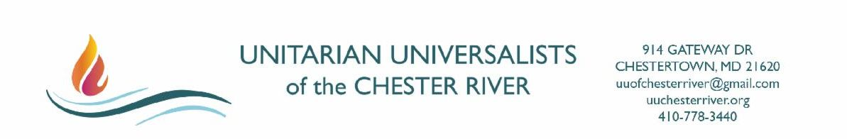
July 1, 2021

Dear UUCR Members and Friends,

We are excited to share that the Unitarian Universalists of the Chester River will return to the sanctuary for in person, indoor summer services starting on Sunday, July 11 at 10 am!

We know the congregation yearns for connection. We had a taste of returning at our first summer service on June 20 (the outdoor service led by Annie Lavin), and we are happy to announce we will move indoors starting July 11. In the sanctuary we'll have the blessing of air conditioning and the sound system, and we will not have to cancel for inclement weather.

We plan to return to the building carefully. While the risks of Covid-19 have decreased dramatically, the virus has by no means gone away. We know some, including families with children under 12 and those with certain underlying medical conditions, face greater risks than others, even with the promise of vaccines. We want to be as inclusive as possible as we return.

What will our first weeks inside the building look like?

The Board appointed a Re-Opening Task Force (Jim Lavin [Chair], Pat Bjorke, Gayle Folger, Jackie Mathwich, and Rev. Sue Browning) to create guidelines for use of the building and property. (Guidelines below.) As we take our first steps to re-gather, we ask everyone to follow these guidelines in a spirit of respect, love and flexibility. As conditions shift, the task force will modify the guidelines.

Our schedule for summer Sunday services is also below. The services will follow the long-held summer tradition at UUCR and be simple, discussion-based services through September 5th.

It has been a long journey since we last met for worship in the sanctuary on March 8, 2020. We are grateful to all who are guiding us back into our space.

We ask for everyone’s patience as together we take these next steps to live out our values in love.

Nancy Holland, Board President
Jim Lavin, Re-Opening Task Force Chair
Worship Committee
Rev. Sue Browning, Minister
Guidelines for 2021 Sunday Summer Services

When Inside:

- A mask must be worn at all times covering both the mouth and nose. This will apply to speakers and congregants.

- All persons entering must sign and date the ledger upon entering the church. This is important and there are no exceptions. This information will be used for Contact Tracing in the unlikely event that an attendee or someone close to the attendee is exposed to the virus.

- The sound system may be used; the mic must be wiped with a sanitizing cloth between speakers.

- At this time, singing is not allowed during the Summer Services. (Recorded music may be used.)

- Restrooms may be used. (Please clean up after use.)

- Food may not be served inside the church at this time. Coffee will not be served.

- Social distancing of three feet (one chair) is required with an exception for families or pods.

- There is no current limit on participation.

- Only use the church if you are non-symptomatic for the Covid-19 virus or any other transmittable disease that could compromise the health of another congregant.

- At this time, please do not use any of the hymnals.

- There are no plans for nursery or childcare.

- The Nursery and the RE rooms are strictly off limits.

- Heavily used items, such as doorknobs, will be wiped with a sanitized prior to the service.

- Please avoid using the office if at all possible.

When Outside:

- Socializing after the services must be done outside. Please bring your own coffee or other beverage. The church will not supply coffee.

- While outside at a church event masks are optional. We encourage everyone to have a mask readily available. Many people have reasons for continuing to wear a mask even if vaccinated. If you prefer to wear a mask please do so, and if you see someone else with a mask on (they have their own reasons) please offer to wear yours.

- We will not require any specific physical distancing, but encourage an atmosphere of caution and culture of respect.

⋘⋙⋘⋙⋘⋙⋘⋙⋘⋙⋘⋙⋘⋙⋘⋙⋘⋙⋘⋙⋘⋙

Schedule for UUCR Summer Services
(Discussion Services)

July 4 - No Service (245th birthday of the USA!)

July 11 - Lynn Dolinger - A service on “Returning”

July 18 - Linda Weimer and Diane Shields - “Who and what make you smile and sometimes laugh out loud?”

July 25 - Rev. Sue Browning - “Deep Inclusion”

August 1 - Amy Warner - “Summer Reading”

August 8 - Vida Morley - “Procrastination”

August 15 - John Ramsey - “Looking for God in all the Wrong Places”

August 22 - Joy Kim - “Calling Forth Baruch Spinoza”

August 29 - The Annual POETRY READING Opportunity!

September 5 - Catherine Brooks - "Racism in Historic Preservation"

