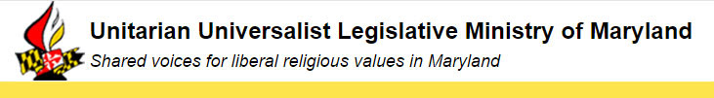

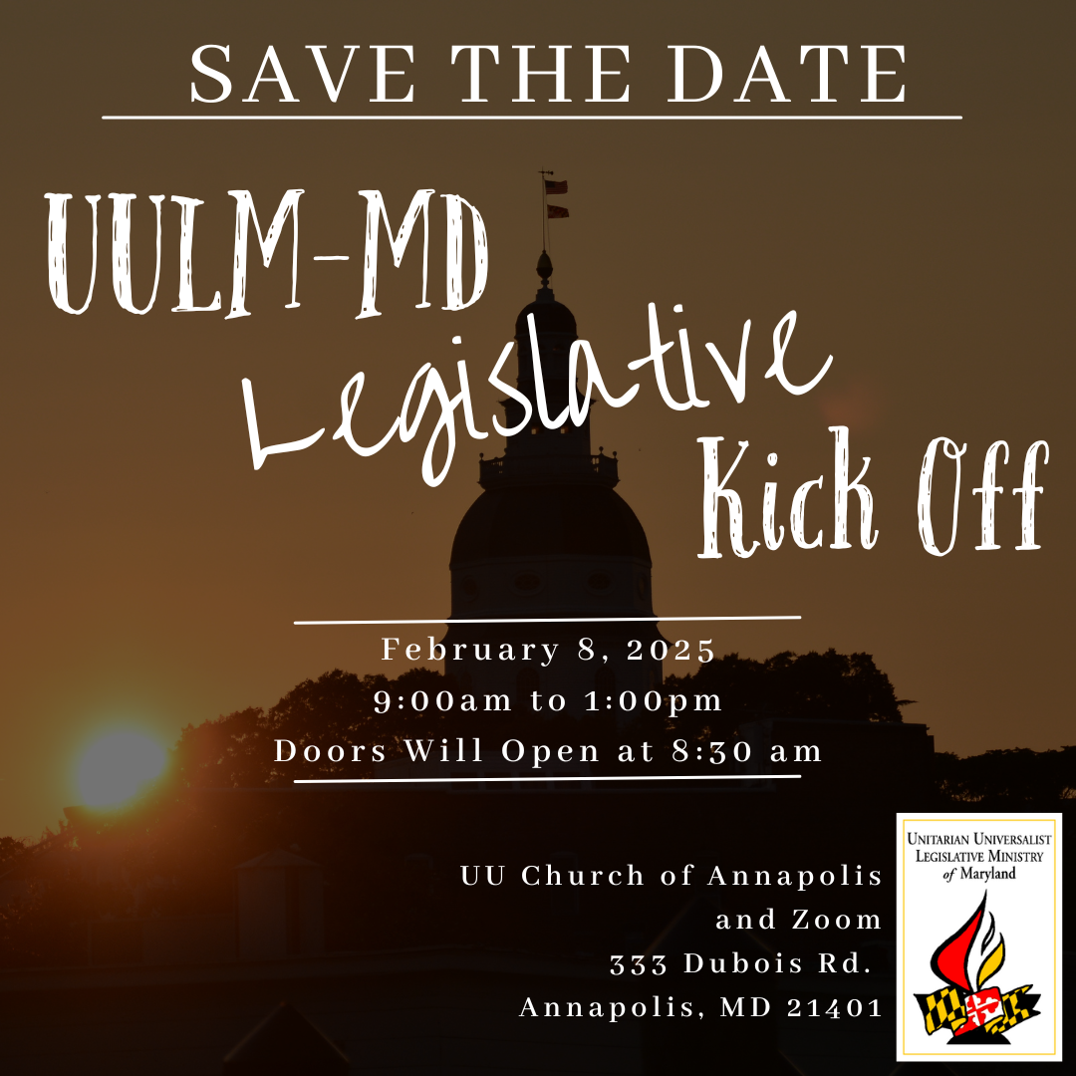

How to Deal with the New Political Environment

  After processing how we feel about the election results, we need to understand the potential impacts and prepare to take action as needed. Much of what we do will be in response to potential actions by Donald Trump and his new administration. There will be consequences that will affect how Maryland manages the State government and what bills it passes in 2025. The Election may also directly impact many Maryland residents, including those who could become pregnant, women in general, immigrants, members of minority groups, and LGBTQ+ people, especially trans folk. It is also possible that nonprofit organizations, including faith groups, will be targeted by the new president. We must be prepared for whatever actions are taken at the federal level.
  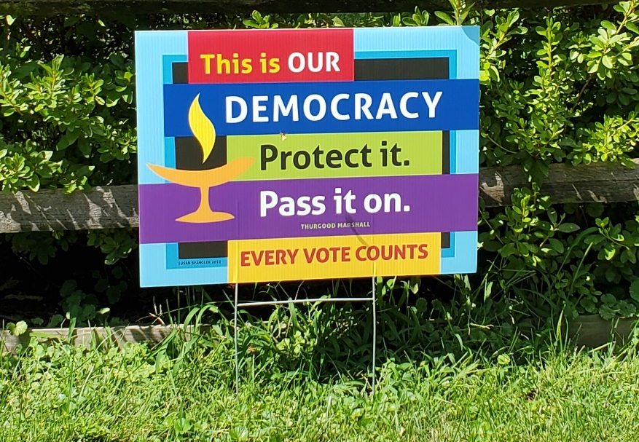

The one thing that we cannot afford is to fall into despair. According to Brene Brown, the antidote is hope, which is not an emotion, but a cognitive-behavioral process that involves setting a goal, a plan to act, and a sense of agency or “I can do this.”
So, let’s get prepared.

After attending and listening to many other groups, UULM-MD recommends several ways to cope:

1. Taking Care of Yourself -

All of us, whether or not we are among a group targeted for harm by the new administration, need to take steps to be prepared during this critical time. Multiple groups advise that we must take care of ourselves before we can protect others and/or act to stop policies that do harm.
Self-care includes:

- Take time for spiritual grounding through programs at UU congregations and utilize the Regional Life staff available for localized support.
- Invite others, especially those living with fear, to join us in our congregations to receive the comfort and love that we all need.
- Reground ourselves in the organizing and social justice skills we learned to help us be effective advocates.
- Reflect on our values and discern what they call on us to do individually and collectively.

2. Building Community Resilience -

The Community Resilience Hub from Side With Love recommends that our congregations and local communities:

- Maintain communication with one another - Check in with your people and keep the lines of communication open.
- Draw on lessons from the pandemic to make sure you have effective communications structures and a nimble strategy for how to make decisions together.
- Pay attention to who is coming in and out of the building when your community is gathered.
- Remember the importance of de-escalation as you take your own measures to support everybody's safety.
- Make sure you are connected with your regional staff, other local congregations, and experienced organizers in your own neighborhood.
- Have conversations now about whose leadership and analysis you will look to for guidance

3. Protecting the Vulnerable

We must work together to protect each other from the threats and disasters already here, as well as those yet to come. Our congregations need to be prepared to welcome an influx of people who will walk through our doors seeking comfort, community, and connection. Their needs may include housing, food, legal services, a safe haven, or just someone to listen and care.

4. Preparing to Act

Dealing with climate disasters and political threats that folks are already experiencing–and those yet to come–may require more than offering comfort and support. It may require advocacy, public witness or even civil disobedience. We may have to take practical steps to blunt the impact of harmful national policies whether perpetrated by the Executive, Legislative or Judicial branches of the Federal Government.
Possible federal actions could include:

- Removing tax exemptions for nonprofits that the new administration could see as being opposed to the new President. One bill already proposed is to allow the President to designate any organization as a terrorist organization, leading to closure and sanctions.
- Impounding budgeted funds to eliminate thousands of federal jobs, which could affect many workers who live in Maryland
- Removing environmental protections and extend delays in climate action
- Blocking access to reproductive healthcare
- Ramping up “abortion surveillance” to intimidate pregnant people who need abortion care
- Ending the legal status of 500,000 Dreamers
- Denying citizenship to children of immigrants born in the United States
- Allowing employers to stop paying hourly workers overtime, affecting at least 420,000 Latino workers--??
- Restricting food stamp eligibility??
- Imposing a specific Christian ideology on public schools
- Using private school vouchers to funnel resources that public schools desperately need into religious schools that would be free to indoctrinate and discriminate
- Reducing funding for schools, ending preschool programs, and eliminating student debt repayment programs
- Emboldening racial discrimination by removing tools that the federal government uses to enforce civil rights protections
- Rolling back civil rights protections and even turning anti-discrimination laws against people who seek to fight systemic racism and advance diversity, equity, inclusion, and accessibility

5. Taking Action and Advocating Where You Can

Beyond helping and protecting, we may also be called upon to act on behalf of individuals in specific groups.

  Advocating Nationally: UUSJ
  Where the cause of the problem is a federal policy or action, we recommend signing up for eNews from UUs for Social Justice regarding one of their action issues:
  - Democracy Action
  - Immigration Action
  - Environment/Climate Action
  - Economic Justice
  If you want to take further action, you should volunteer with one of UUSJ’s Action Teams to support or oppose federal legislation, join nationwide letter-writing campaigns, or participate in public rallies.
  Advocating In Maryland: UULM-MD
  Where the problem can be addressed at the state level, stay informed by reading our weekly Digests and find resources on our website.
  State actions could include:
  - Asking the Governor to make it much harder for Trump to use military force to grab and detain millions of immigrants as part of his threatened mass deportations
  - Asking the Attorney General to file or join lawsuits against proposed federal actions.
  - Contacting lawmakers in support of our priority issues in order to keep Maryland moving forward.

  Sign Up for UUSJ E-News and Updates
  Volunteer with UULM-MD

Advocating By Issue:

The policies that fall under each of our Issue Teams could be affected by federal agencies, policies, and courts in different ways, including:

- Criminal Justice: is almost exclusively a state matter, we expect little from the federal government that would impact our efforts to reform and improve our justice system.
- Medical Aid in Dying: is also a state matter and cannot be negatively impacted by federal policy.
- Health Care: is generally a state matter, so regulation of prescription drug costs is likely safe from federal action.
- Reproductive Rights: are now protected by the Maryland Constitution due to the success of the amendment at the ballot box. However, the federal government could endanger medical abortions by enforcing the Comstock Act passed decades ago prohibiting such products from being shipped through the US Postal Service (alternative delivery means could be made available).
- Gun Violence Prevention: Maryland’s progressive gun laws are subject to challenge in federal courts so lawsuits, rather than executive pronouncements, could affect whether they succeed in reducing gun violence in our state.
- Climate Change: Maryland’s efforts to address the climate crisis are independent of federal control, but they could be affected by efforts to redirect funding from renewables to the fossil fuel industry.
- Immigration: is essentially a federal matter, but states can take steps to make immigrants more welcome. Most of our recent legislative actions are along these lines, but federal actions could still make immigration harder for many Maryland residents.

Over the next month, each of our Issue Leads will be providing more detailed information about the prospects of success in the 2025 Maryland General Assembly. Please Save the Date, February 8th, 2024 from 9:00am to 1:00pm for the UULM-MD Legislative Kick Off, which will occur at the UU Church of Annapolis and on Zoom. Before the Kick Off, we will have a briefing via Zoom, as well.
Please counter any despair by fostering hope: follow your goals, plan your actions, and know that together “We can do this!”
Take Care and Good Luck,
All of us at UULM-MD

Donate to UULM-MD

Donate

A program of the UU Church of Annapolis.

Unitarian Universalist Legislative Ministry of Maryland
333 Dubois Rd
Annapolis, MD 21401
United States

 |  | 

If you believe you received this message in error or wish to no longer receive email from us, please unsubscribe.

