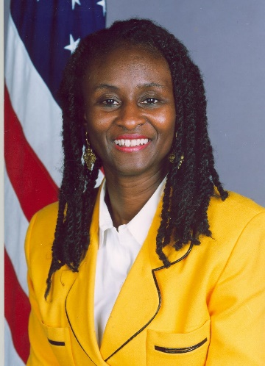
Ambassador (Dr.) Robin Renee Sanders – CEO FEEEDS Sanders served as one of the U.S. Government’s top diplomats on African issues over a long career in the United States Diplomatic Corps reaching senior positions ranging from Ambassador to the Republics of Nigeria, Republic of Congo, two stints – NSC Director for Africa at the White House, and U.S. Permanent Representative to the West African Regional Organization ECOWAS. Dr. Sanders received her doctor of science degree in information systems and communications from Pittsburgh’s Robert Morris University, where she also holds the title of Distinguished Public Service & Rooney Scholar. Sanders is also a Gallup Senior Scientist. The Ambassador also holds MA and MS degrees from Ohio University; and, a BA from Hampton University. She is a recognized Africa Region thought-leader on subjects ranging from Africa's SMEs, trade, political, economic, and technology issues as well as US-Africa policy. Her work also focuses on the region’s thematic topics such as the UNSDGs, food security, democracy/elections, education and climate change. She has testified before the U.S. Congress on many of these topics.
Her advisory firm is divided into two parts: The FEEEDS Advocacy Initiative and FE3DS, LLC. FEEEDS focuses on Africa economic development, Diaspora, Entrepreneurship/SMEs issues. FEEEDS also advises several organizations; co-hosts an annual Africa event with Gallup World Poll; and publishes @The FEEEDS Index, which features Gallup World Poll Africa development data. Sanders' national security expertise is based on her work at the White House; as Deputy Commandant-Eisenhower College, at the National Defense University, the U.S. military's premier institution for military and strategic studies; her diplomatic postings; and her work on global issues. FE3DS, LLC provides business strategies on Africa trade, technology, power, renewables, aviation, affordable housing and aviation.
Hosts Biographies – FEEEDS & GALLUP World Poll

Awards & Key Memberships: U.S. military’s Joint Chiefs of Staff Civilian Honor Award, Medal of Honor Republic of Congo, six State Department awards (Superior & Meritorious); Member - U.S. Trade Representative Africa Committee (focus on Africa SMEs); the prestigious American Academy of Diplomacy & American College of National Security Leaders of former senior U.S. Government officials; and National Society of Scholars for her public policy & academic work. Sanders, as CEO-FEEEDS, serves on several non-profit and corporate boards and has received several leadership awards for her advocacy work on Africa, and for the Africa Diaspora and Africa SMEs.

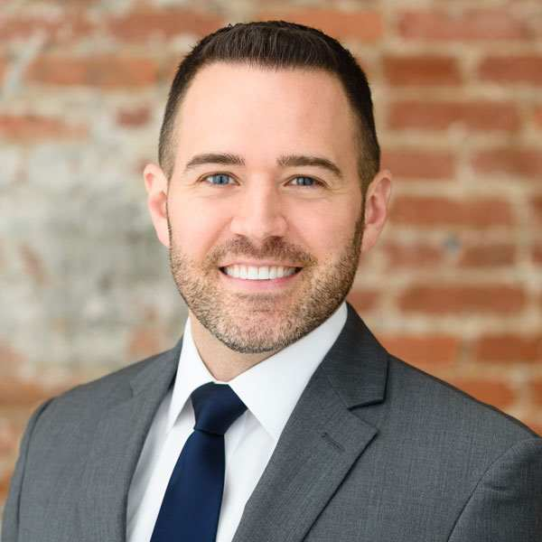
Jon advises global leaders on how to make their organizations and countries thrive using analytics-based insights

Jon Clifton is Global Managing Partner at Gallup. His mission is to help 7 billion citizens be heard on their most pressing work and life issues through the Gallup World Poll, a 100-year initiative spanning over 150 countries.
Clifton is a nonresident senior fellow at Baylor University's Institute for Studies of Religion. He serves on the boards of directors for Gallup and Young Professionals in Foreign Policy, and he previously served on the boards for three nonprofits and a startup -- Meridian International Center, StreetWise Partners, Chess Challenge in DC and Findyr.
Because of his expertise, Clifton has been interviewed on BBC News, C-SPAN's "Washington Journal" and Al-Jazeera, and he has testified in front of the U.S. Congress on the state of American small business and entrepreneurship. He is a frequent contributor on Gallup.com and has written for The Hill, The Diplomatic Courier and The Global Action Report.
Clifton received a bachelor's degree in political science and history from the University of Michigan and a Juris Doctor in international law from the University of Nebraska. He was also awarded an honorary doctorate in humane letters from Midland University.
EDUCATION
University of Michigan
Bachelor's Degree, Political Science
University of Nebraska-Lincoln
Juris Doctor, International Law

