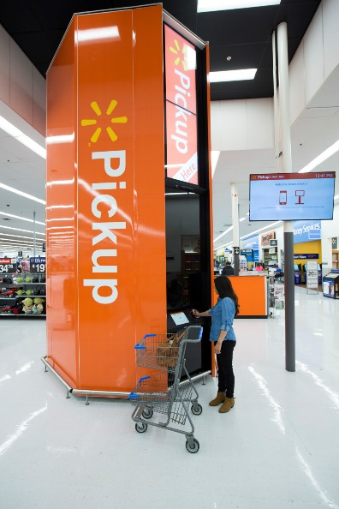

Steubenville Walmart Supercenter Fifth in Ohio
to Debut Pickup Tower Technology
Tower project is part of the retailer’s investment in serving today’s customers

Steubenville, OH, January 30, 2018 – The Walmart Supercenter at 100 Mall Drive in Steubenville will be the fifth store in Ohio to debut the company’s Pickup Tower technology. These 16-foot tall structures function like high-tech vending machines and can fulfill a customer’s online order in less than a minute. The Pickup Tower will be operational starting today (January 30th).
To use the Pickup Tower, customers simply choose from millions of items available on Walmart.com and select the Pickup option at checkout. When the item arrives at the local store, an associate loads it into the Pickup Tower and the customer retrieves by scanning a bar code sent to their smartphone. Pickup Towers are the latest example of Walmart’s commitment to digital acceleration and innovation, as well as convenience, helping customers save time and shop however, whenever, wherever they want.
“The Pickup Tower pilot phase has been so successful Walmart is expanding it to additional locations across the country – and we’re proud to bring it to Steubenville,” said Walmart Market Manager George Tirch. “This technology is designed to give time back to our customers with a new shopping experience.
"Very simply put, you walk in, you have a code. You walk up to the machine, enter your information and it finds your packages. You just grab it out of the machine and walk out,” Tirch said.
Last October, Walmart shared it is investing around $6 billion this fiscal year in the U.S. in store growth, store remodels and other innovations.
Shop How, Where and When You Want: Convenience Offerings
Walmart is innovating the shopping experience like no one else – so customers can shop when and how they want.
- Customers can shop nearly 50 million items on Walmart.com.
- Walmart also gives customers the power of choice; Pickup Discount gives customers a discount on select items if they choose to pick up their Walmart.com order at a store.
- In addition, free 2-Day shipping is offered with no extra cost for orders of $35 or more.
- The Walmart mobile app for iPhone and Android makes shopping easier than ever. By using the Walmart mobile app, customers can create shopping lists, search the location of items in their store, check weekly ads and prices, save e-receipts and shop Walmart.com.

Job Opportunities
At Walmart, associates have access to competitive wages, affordable benefits, and the chance to build a career. More than 75 percent of store management teams started as hourly associates and 40 percent of those promotions went to associates within the first year of their employment.

About Walmart
Wal-Mart Stores, Inc. (NYSE: WMT) helps people around the world save money and live better - anytime and anywhere - in retail stores, online, and through their mobile devices. Each week, nearly 260 million customers and members visit our 11,593 stores under 63 banners in 28 countries and e-commerce websites in 11 countries. With fiscal year 2017 revenue of $486 billion. Walmart employs approximately 2.4 million associates worldwide. Walmart continues to be a leader in sustainability, corporate philanthropy and employment opportunity. Additional information about Walmart can be found by visiting http://corporate.walmart.com on Facebook at http://facebook.com/walmart and on Twitter at http://twitter.com/walmart.
# # #
Contact:
Mark Rickel
Lesic & Camper Communications
614.232.8309

