Weekly Schedule for August 7th – August 14th

Sunday, August 7 – Sunday Worship – 10:30 a.m.

Monday –

Tuesday – Highland Quilters- 9am.

Wednesday – OA – Noon

Thursday – Girl Scouts – 7:00 p.m. in the Fellowship Hall.

Friday -

Saturday – Presbytery Meeting. Madisonville, TN

Sunday, August 14 – Sunday Worship, 10:30 a.m. Session & Mission Committee, 11:30 a.m.

Highland Presbyterian Church
721 East Lamar Alexander Parkway, Maryville, TN 37804
(865) 982-9272 www.highlandpresby.org

Pastor: Rev. Matthew Benz-Whittington matthew@highlandpresby.org
Choir Director & Organist: Jussara Horton hortonjussara@gmail.com
Communications Director: Tabby Parker communications@highlandpresby.org
Office Administrator: William Martin. (Tues. & Thurs. 10 a.m. – 2 p.m.) office@highlandpresby.org
Church Accountant: Rebecca Wade financehighlandpresby@gmail.com
Sunday School Teachers: Lucy Reddick
Nursery Care: Rosalinda Oceguera
Facebook: Facebook.com/HighlandPC Instagram: highlandpresmaryville
Highland Presbyterian Church
August 7th, 2022
Holy Communion Sunday
10:30 a.m.
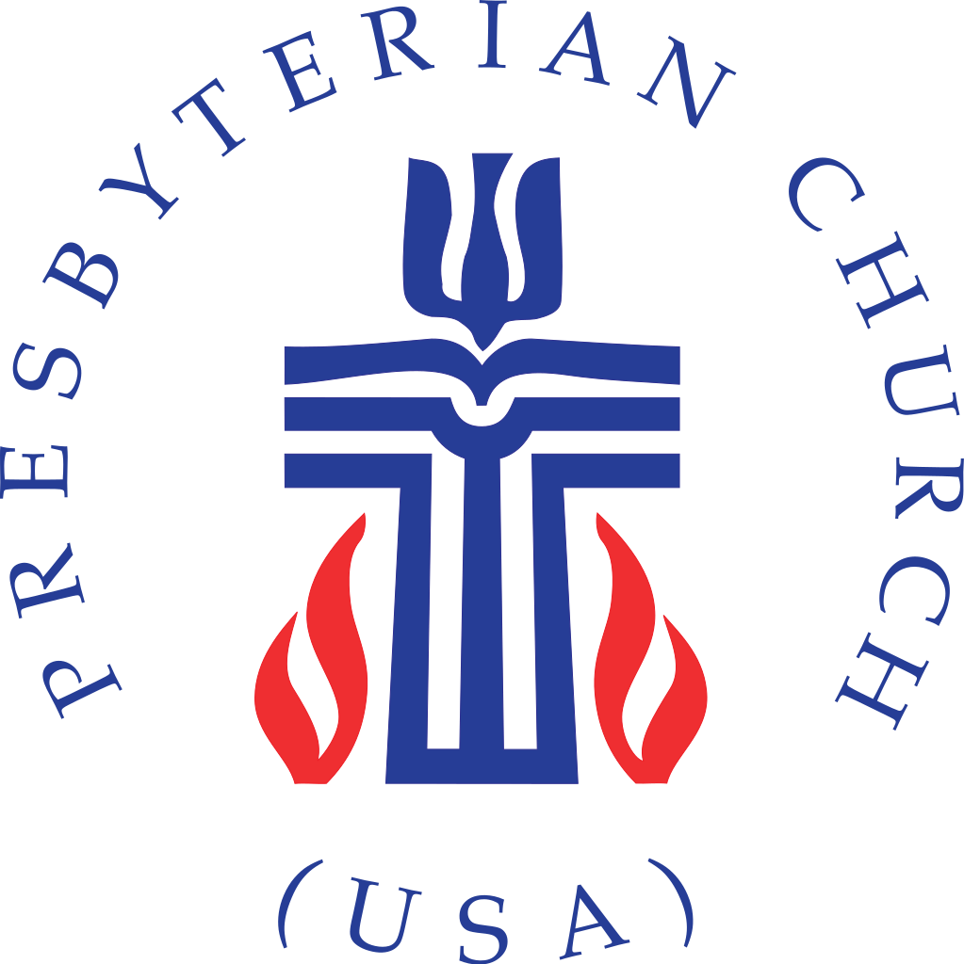

“Sell your possessions, and give alms. Make purses for yourselves that do not wear out, an unfailing treasure in heaven, where no thief comes near and no moth destroys. For where your treasure is, there your heart will be also.”

Highland Presbyterian Church​ seeks to be a diverse and inclusive Christian Community as we embody the love and forgiveness of Jesus by serving the Community and the World, drawing people to Christ.
Prelude
Gathering

Welcome & Announcements Rev. Matthew Benz-Whittington

Call to Worship (Responsive)

One: The heavens declare the righteousness of God.
All: The earth declares God’s beauty.
One: From the rising of the sun to its setting
All: God’s word shines forth in glory.
All: Let us worship God!

*Opening Hymn We Walk By Faith and Not By Sight Hymn 817

Call to Confession

Prayer of Confession (Communal)

Holy God, you call us to do good, seek justice, and care for those in need, yet how often we place our own comforts above compassion for others. Forgive us, we pray, and cleanse us from these and all our offenses through Jesus Christ our Lord. Amen.

Assurance of Pardon (Responsive)

One: In Jesus Christ you have been set free. Know that you are forgiven and be at peace.

All: Thanks be to God!

*asterisk indicated where to stand in body or in spirit
Sending

*Closing Hymn In the Bulb, There is a Flower Hymn 250

*Charge and Benediction

Postlude

Upcoming Events
Next MAY Event

On Sunday, August 28, youth from St. Andrew’s Episcopal and Presbyterian churches from Knoxville will gather together at the Ropes Course at Maryville College with Mountain Challenge. This event will be from 4-8 pm and will include games, dinner and will be $10 a person. RSVP to Pastor Matthew
Women’s Circle Return in September
Highland’s Presbyterian Women’s Circle will take the summer months of July and August off, and will return on Thursday, September 1, 2022 to meet at 1:30 pm in the church parlor. At that time, we will begin our new PW Bible study for the 2022-2023 year: “Celebrating Sabbath: Accepting God’s Gift of Rest and Delight” by Carol M. Bechtel and Laura Mariko Cheifetz.
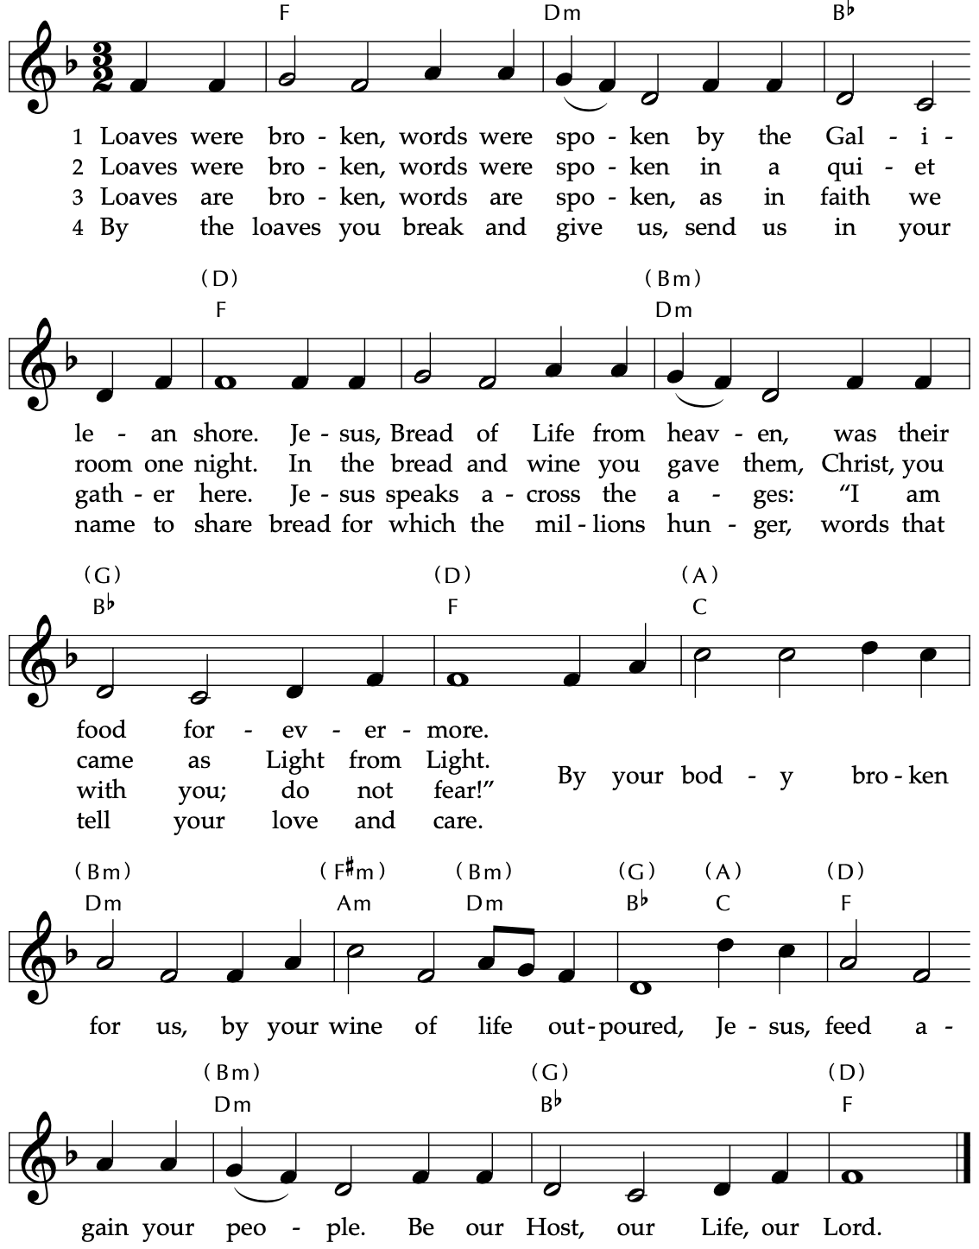
Communion Music Loaves Were Broken, Words Were Spoken Hymn 498
Time for the Children Rev. Matthew Benz-Whittington

The Word

Prayer for Illumination

God of Hope, by faith we know that you created the world, and that what is seen is made by things that are not visible. Open our eyes to your presence among us that we may hear your word with clarity and a sureness of hope, as we follow you in all righteousness. Through Jesus Christ, our Lord. Amen.

Holy Scripture Luke 12:32—40

‘Do not be afraid, little flock, for it is God’s good pleasure to give you the kingdom. Sell your possessions and give alms. Make purses for yourselves that do not wear out, an unfailing treasure in heaven, where no thief comes near, and no moth destroys. For where your treasure is, there your heart will be also.
‘Be dressed for action and have your lamps lit; be like those who are waiting for their master to return from the wedding banquet, so that they may open the door for him as soon as he comes and knocks. Blessed are those slaves whom the master finds alert when he comes; truly I tell you, he will fasten his belt and have them sit down to eat, and he will come and serve them. If he comes during the middle of the night, or near dawn, and finds them so, blessed are those slaves.
‘But know this: if the owner of the house had known at what hour the thief was coming, he would not have let his house be broken into. You also must be ready, for the Son of Man is coming at an unexpected hour.’

Sermon Rev. Matthew Benz-Whittington

*Hymn Keep Your Lamps Trimmed and Burning Hymn 350

Statement of Faith (Communal) Excerpts from A Brief Statement of Faith (PC(USA))

In life and in death we belong to God. Through the grace of our Lord Jesus Christ, the love of God, and the communion of the Holy Spirit, we trust in the one triune God, the Holy One of Israel, whom alone we worship and serve.
We trust in Jesus Christ, fully human, fully God. Jesus proclaimed the reign of God: preaching good news to the poor and release to the captives, teaching by word and deed and blessing the children, healing the sick and binding up the brokenhearted, eating with outcasts, forgiving sinners, and calling all to repent and believe the gospel.
With believers in every time and place, we rejoice that nothing in life or in death can separate us from the love of God in Christ Jesus our Lord.
Offering of Our Gifts

Offertory

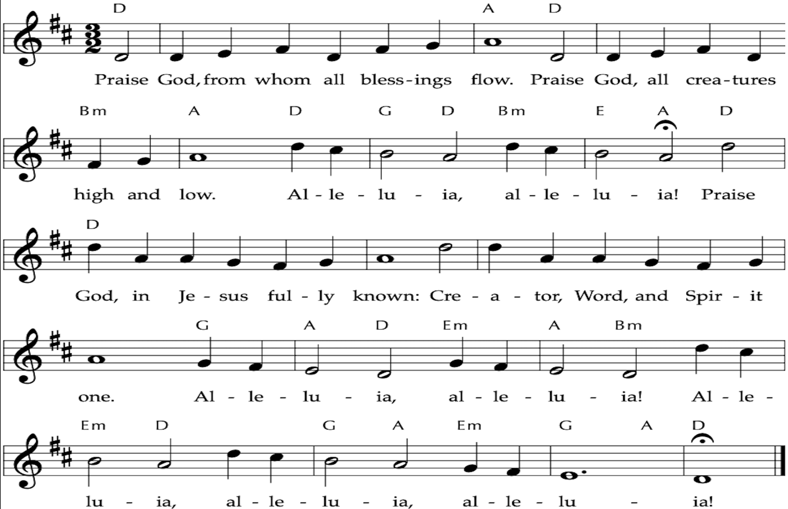
Doxology Hymn 609
*Prayer of Thanksgiving (Communal)

Generous God, you pour out blessing and cover us with gifts of love. Accept these offerings for the sake of your children, that they may proclaim your mercy and embody your grace. In Jesus’ name we ask it. Amen.

Eucharist

Invitation

Great Prayer of Thanksgiving (Responsive)

One: The Lord be with you
All: And also with you
One: Lift up your hearts.
All: We lift them to the Lord.
One: Let us give thanks to the Lord our God.
All: It is right to give our thanks and praise.

Communion & Prayers of the People

Lord’s Prayer

Our Father who art in heaven, hallowed be thy name. Thy kingdom come, thy will be done, on earth as it is in heaven. Give us this day our daily bread; and forgive us our debts, as we forgive our debtors; and lead us not into temptation, but deliver us from evil. For thine is the kingdom and the power and the glory, forever. Amen.

